Polygonal Path
# Source: AI Source: Provided by: [Data Path: Persons Table -> ID Column: 1, Name_En Column: Motasem Essam] -> From: [ChatGPT] on [7/25/2026]
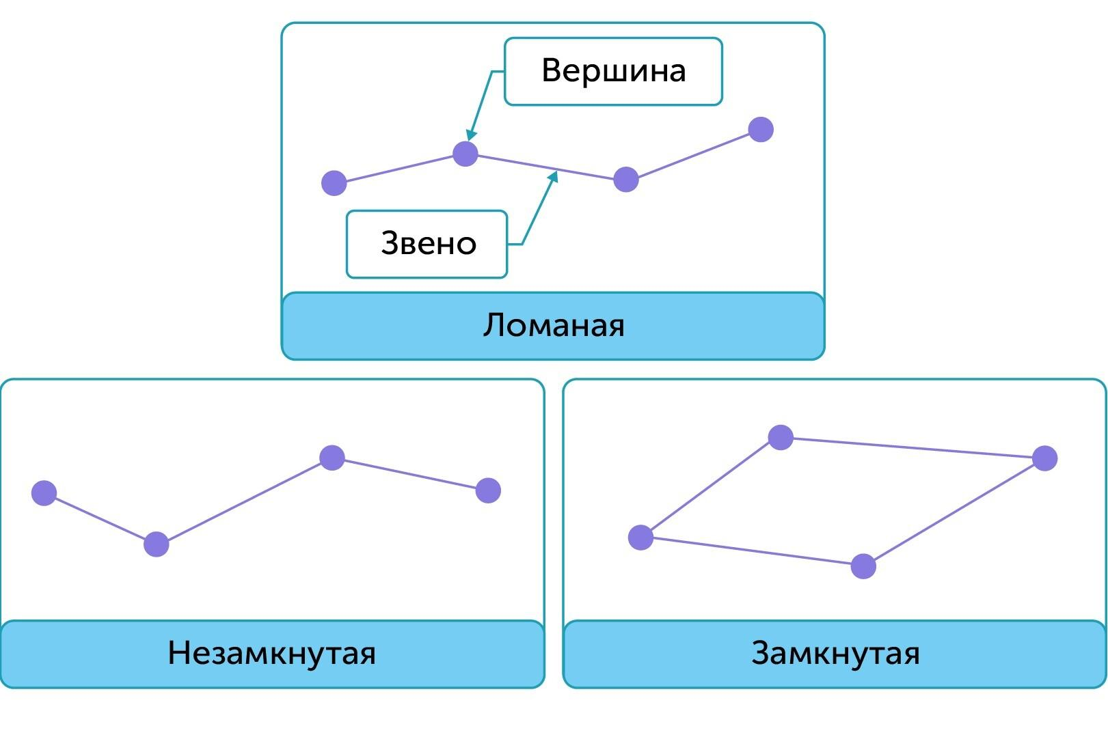
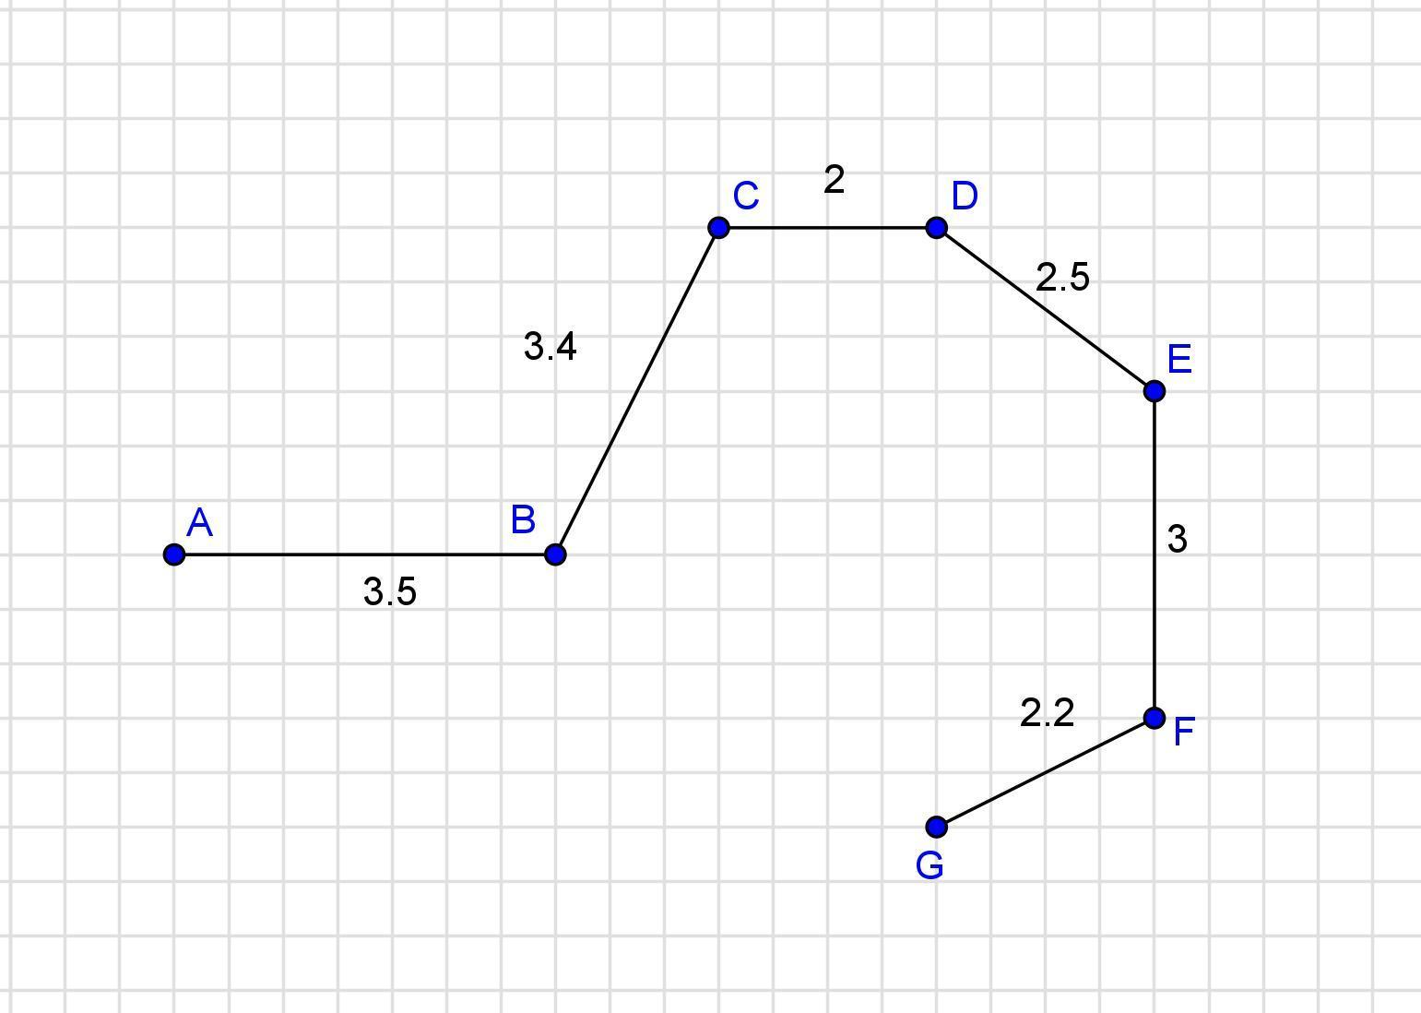
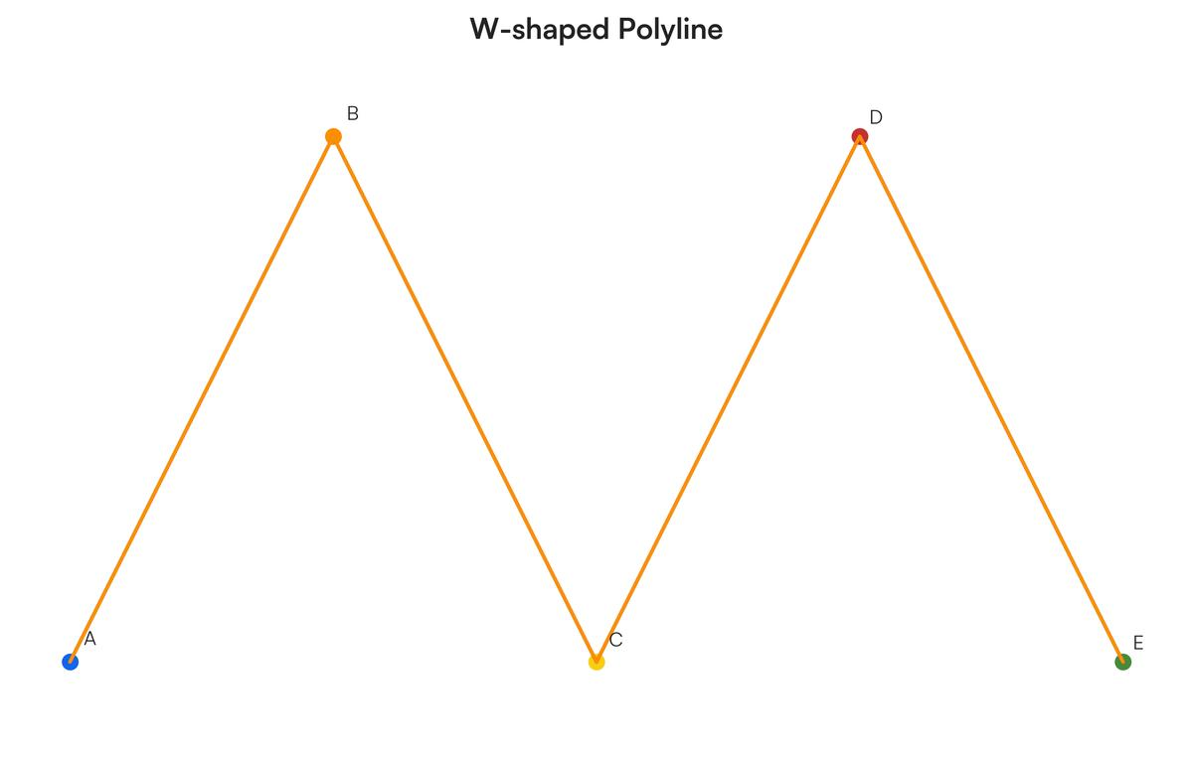
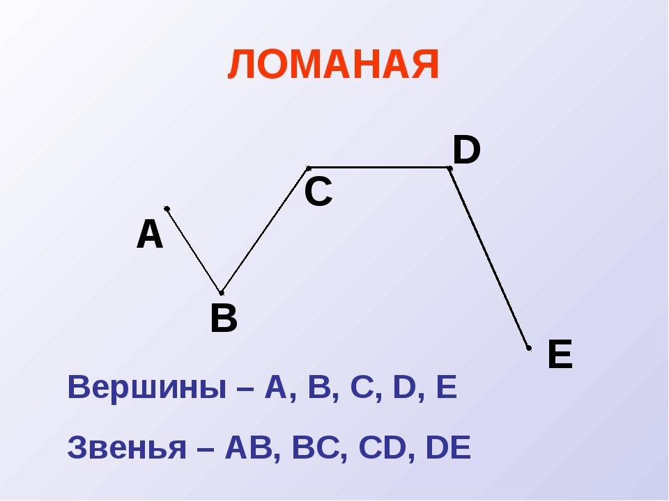
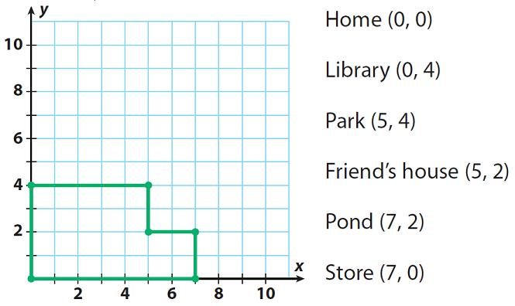

Definition
# Source: AI Source: Provided by: [Data Path: Persons Table -> ID Column: 1, Name_En Column: Motasem Essam] -> From: [ChatGPT] on [7/25/2026]
A Polygonal Path is a geometric path formed by a finite sequence of straight-line segments connected end-to-end at vertices.
If the vertices are
$$P_{0},P_{1},P_{2},…,P_{n}$$
then the polygonal path consists of the segments
$$\boxed{\overset{‾}{P_{0}P_{1}}∪\overset{‾}{P_{1}P_{2}}∪⋯∪\overset{‾}{P_{n-1}P_{n}}}$$
Each segment is called an edge or link, and each connecting point is called a vertex.
Simple Definition
A Polygonal Path is a path made by connecting several straight-line segments end-to-end.
For example:
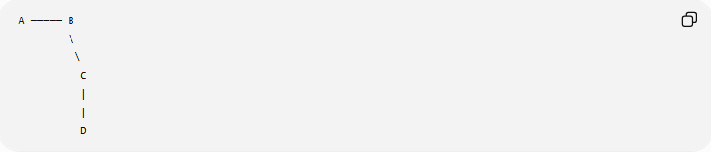
A ───── B
\
\
C
|
|
D
The path is:
$$A→B→C→D$$

Main Classification
# Source: AI Source: Provided by: [Data Path: Persons Table -> ID Column: 1, Name_En Column: Motasem Essam] -> From: [ChatGPT] on [7/25/2026]
A practical classification of polygonal paths is:
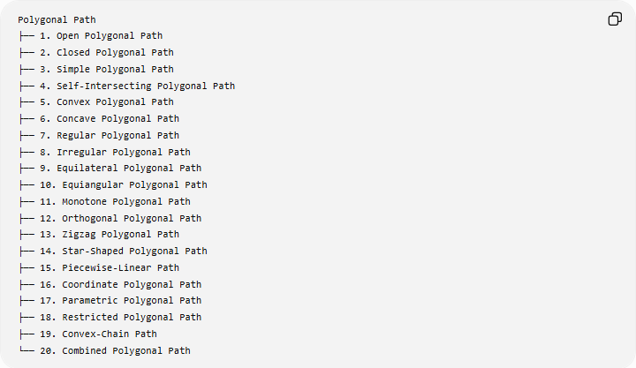
Polygonal Path
├── 1. Open Polygonal Path
├── 2. Closed Polygonal Path
├── 3. Simple Polygonal Path
├── 4. Self-Intersecting Polygonal Path
├── 5. Convex Polygonal Path
├── 6. Concave Polygonal Path
├── 7. Regular Polygonal Path
├── 8. Irregular Polygonal Path
├── 9. Equilateral Polygonal Path
├── 10. Equiangular Polygonal Path
├── 11. Monotone Polygonal Path
├── 12. Orthogonal Polygonal Path
├── 13. Zigzag Polygonal Path
├── 14. Star-Shaped Polygonal Path
├── 15. Piecewise-Linear Path
├── 16. Coordinate Polygonal Path
├── 17. Parametric Polygonal Path
├── 18. Restricted Polygonal Path
├── 19. Convex-Chain Path
└── 20. Combined Polygonal Path

1. Open Polygonal Path
# Source: AI Source: Provided by: [Data Path: Persons Table -> ID Column: 1, Name_En Column: Motasem Essam] -> From: [ChatGPT] on [7/25/2026]
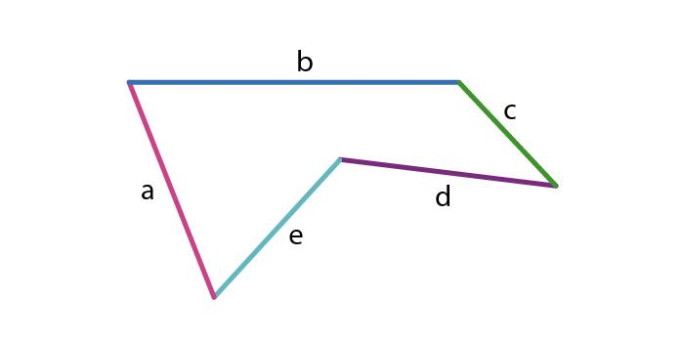
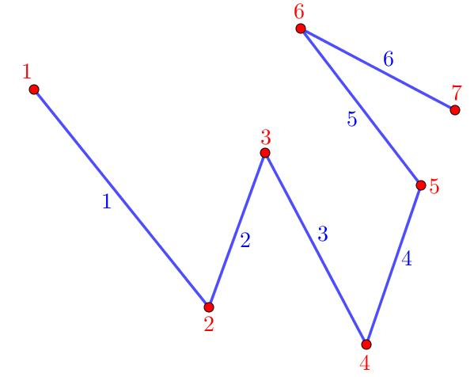
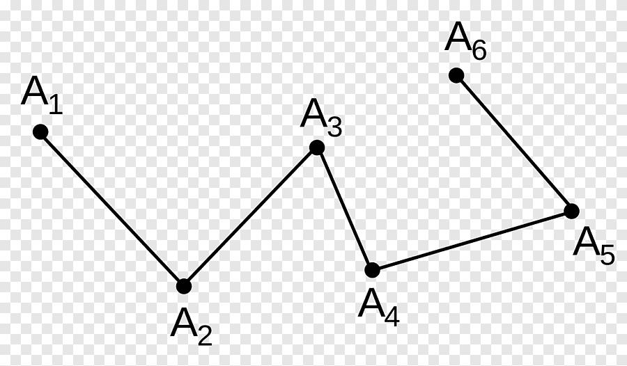
Definition
An Open Polygonal Path is a polygonal path whose starting point and ending point are different.
$$\boxed{P_{0}≠P_{n}}$$
The path does not return to its starting point.
Example

A ─── B
\
C ─── D
The path is:
$$A→B→C→D$$
It starts at $A$and ends at $D$.
Key Property
$$\boxed{\text{Start Point}≠\text{End Point}}$$
An open polygonal path is a path, but it does not form a closed polygonal boundary.

2. Closed Polygonal Path
# Source: AI Source: Provided by: [Data Path: Persons Table -> ID Column: 1, Name_En Column: Motasem Essam] -> From: [ChatGPT] on [7/25/2026]
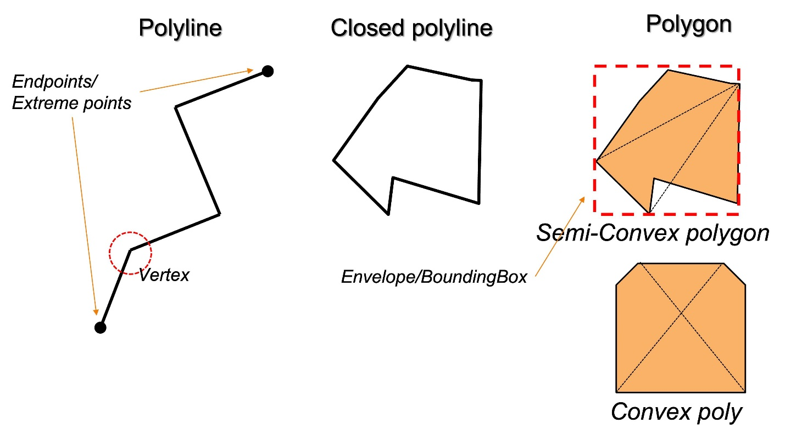
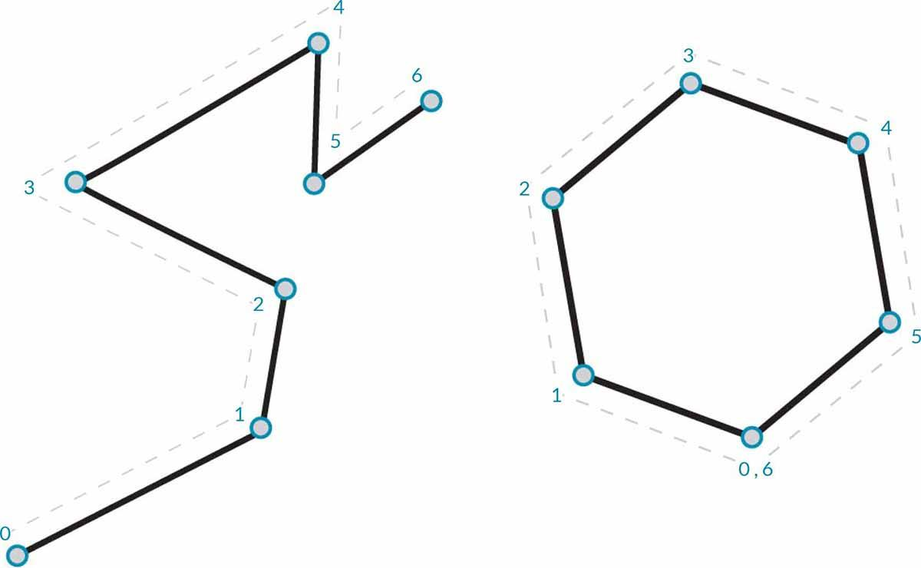
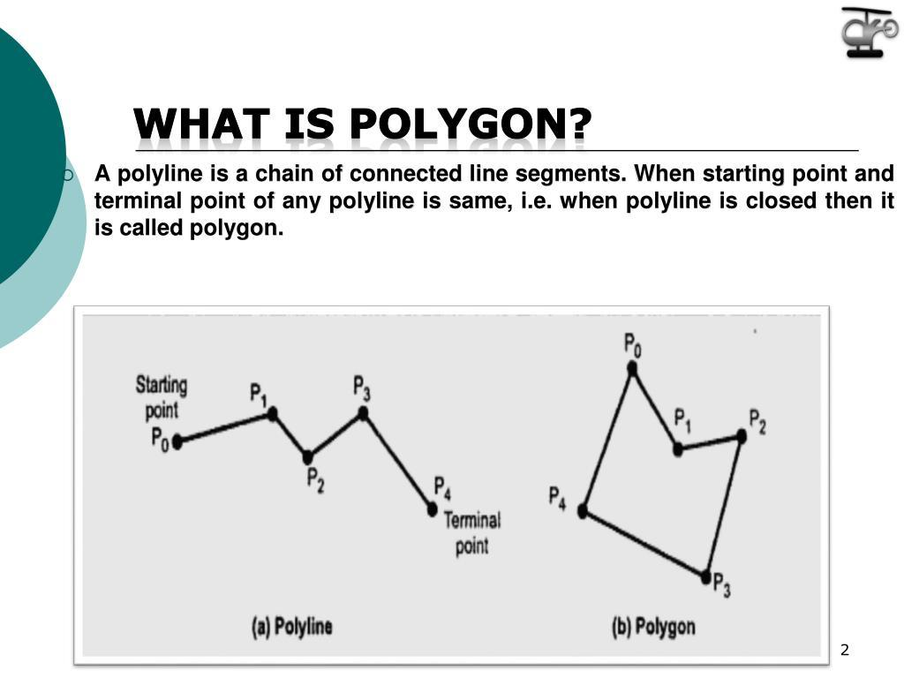
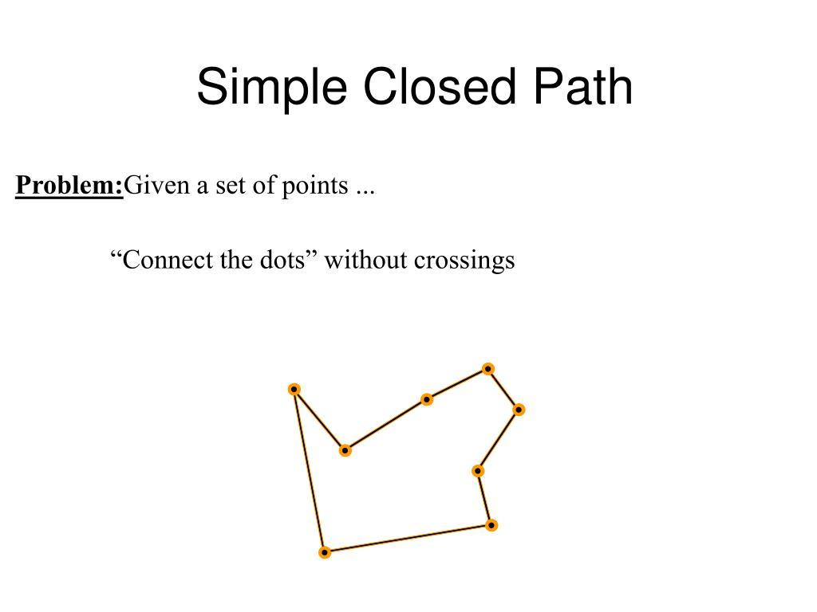
Definition
A Closed Polygonal Path is a polygonal path whose starting point and ending point are the same.
$$\boxed{P_{0}=P_{n}}$$
Example
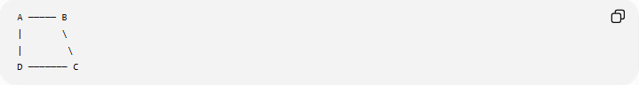
A ───── B
| \
| \
D ─────── C
The path is:
$$A→B→C→D→A$$
Key Property
$$\boxed{\text{Start Point}=\text{End Point}}$$
A simple closed polygonal path forms the boundary of a polygon.

3. Simple Polygonal Path
# Source: AI Source: Provided by: [Data Path: Persons Table -> ID Column: 1, Name_En Column: Motasem Essam] -> From: [ChatGPT] on [7/25/2026]
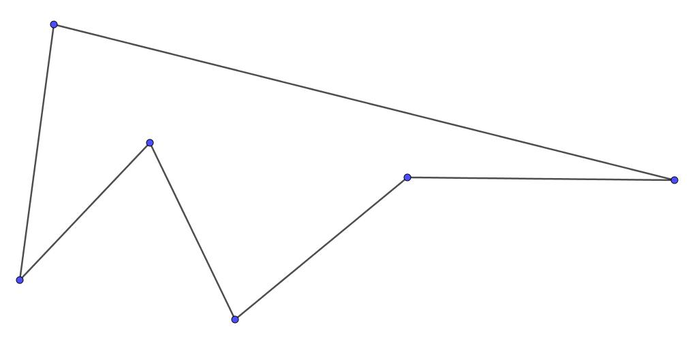
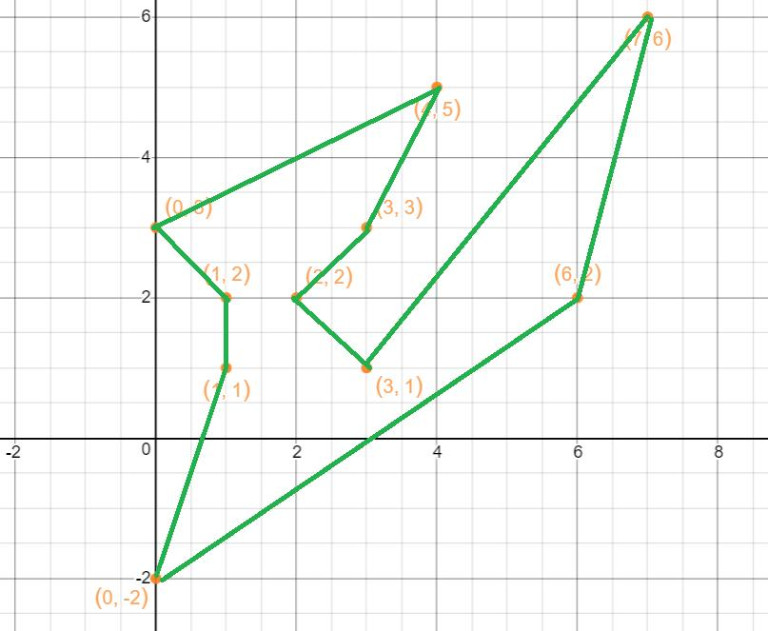
Definition
A Simple Polygonal Path is a polygonal path in which nonconsecutive segments do not intersect.
For a simple open path, segments do not cross one another except at their common consecutive endpoints.
Example
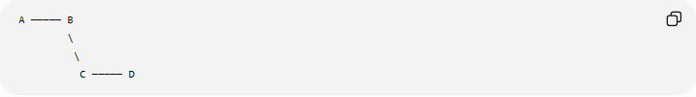
A ───── B
\
\
C ───── D
No nonconsecutive segments cross.
Importance
A simple closed polygonal path can form the boundary of a simple polygon.

4. Self-Intersecting Polygonal Path
# Source: AI Source: Provided by: [Data Path: Persons Table -> ID Column: 1, Name_En Column: Motasem Essam] -> From: [ChatGPT] on [7/25/2026]
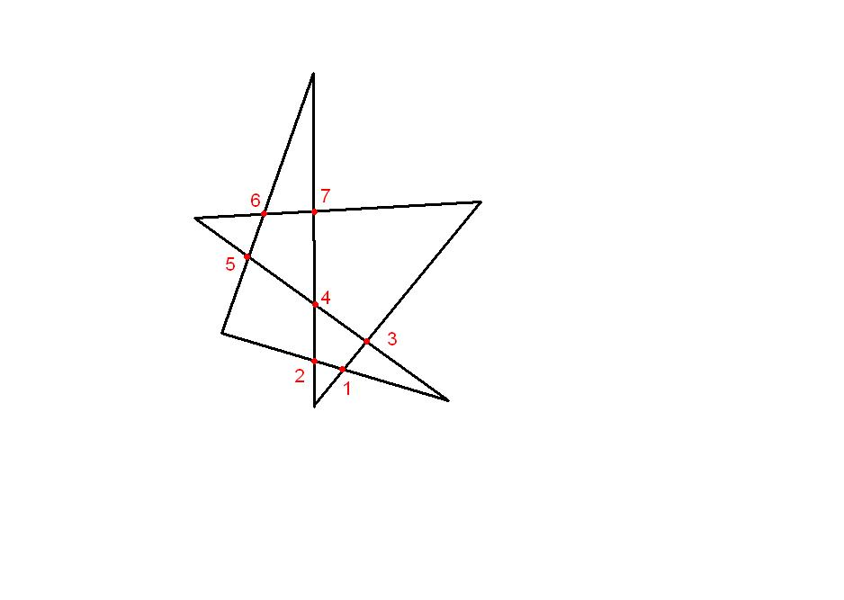
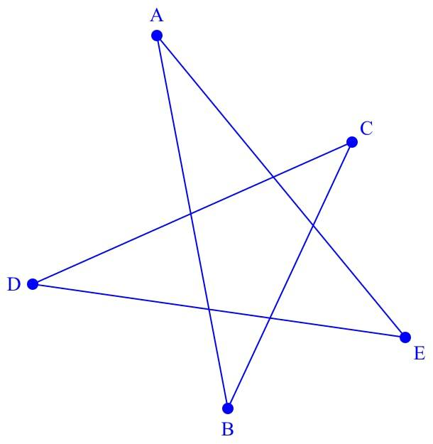
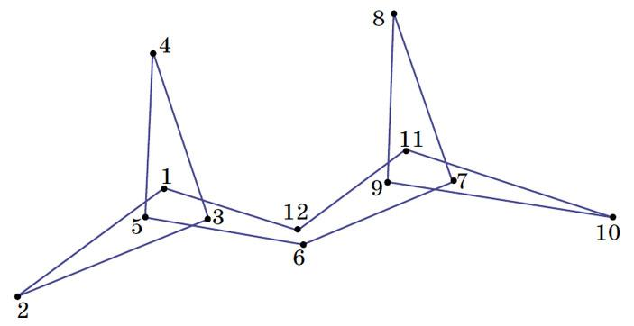
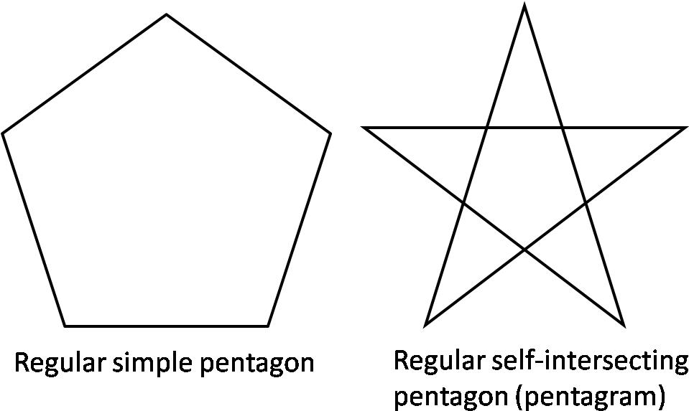
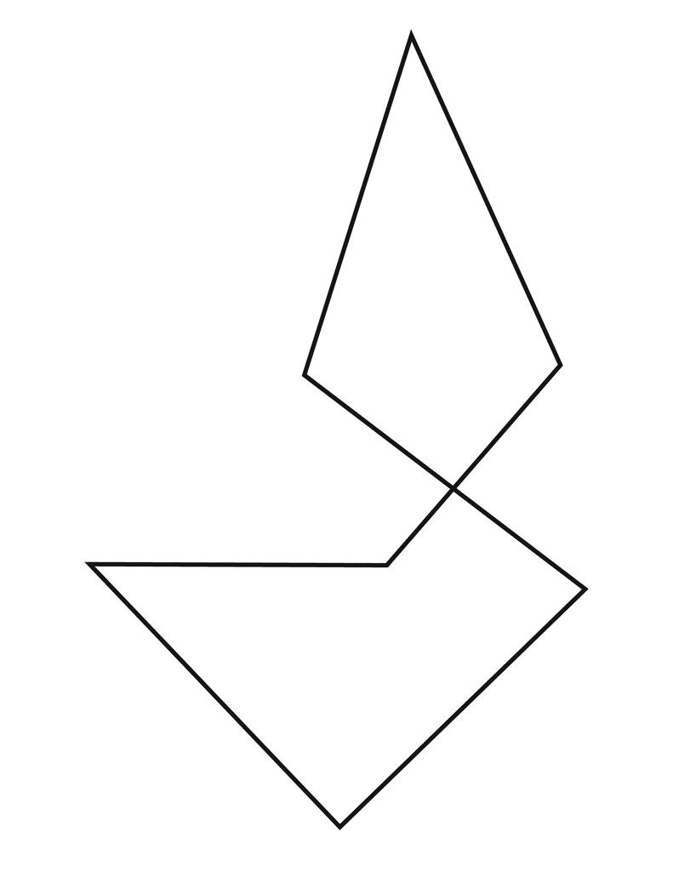
Definition
A Self-Intersecting Polygonal Path is a polygonal path in which at least two nonconsecutive segments intersect.
Example
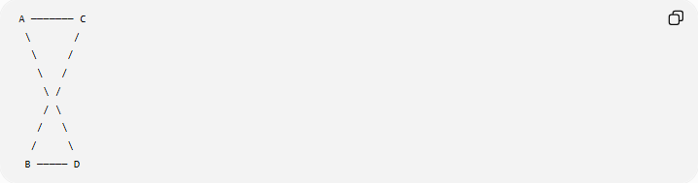
A ─────── C
\ /
\ /
\ /
\ /
/ \
/ \
/ \
B ───── D
Some segments cross away from their common endpoints.
Important Distinction
A self-intersecting polygonal path is not a simple polygonal path.
A closed self-intersecting path may produce shapes such as a star-like polygon.

5. Convex Polygonal Path
# Source: AI Source: Provided by: [Data Path: Persons Table -> ID Column: 1, Name_En Column: Motasem Essam] -> From: [ChatGPT] on [7/25/2026]
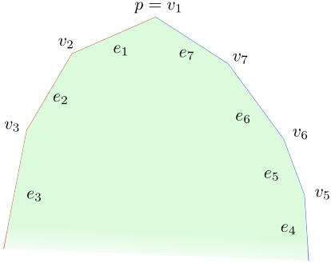
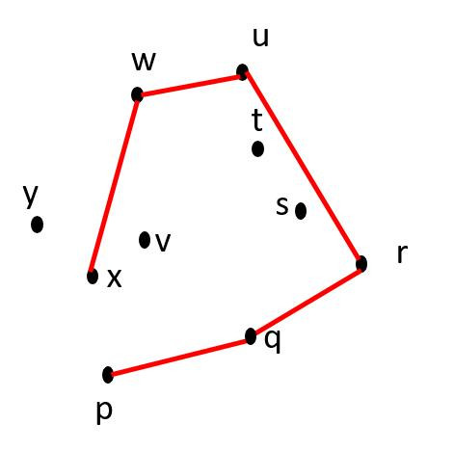
The term convex polygonal path is mainly useful when discussing a polygonal chain that forms part of a convex boundary.
Definition
A polygonal path is a convex chain when its successive turns are consistently oriented and the chain forms part of the boundary of a convex region.
Example
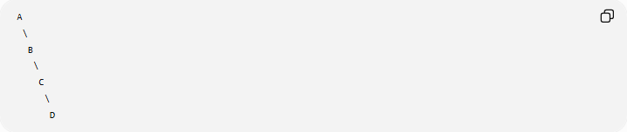
A
\
B
\
C
\
D
The chain bends consistently in one direction.
Important Note
"Convex polygonal path" is less standardized than convex polygon. For a closed figure, it is usually more precise to say convex polygon.

6. Concave Polygonal Path
# Source: AI Source: Provided by: [Data Path: Persons Table -> ID Column: 1, Name_En Column: Motasem Essam] -> From: [ChatGPT] on [7/25/2026]
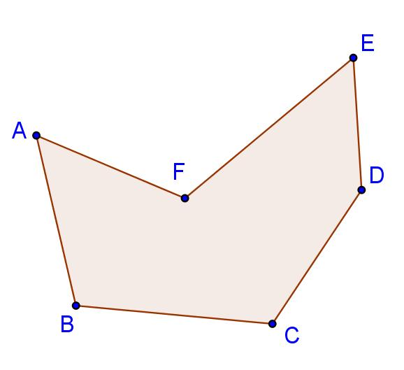
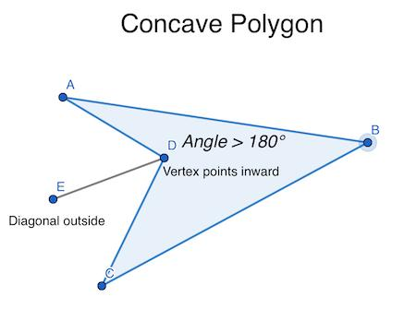
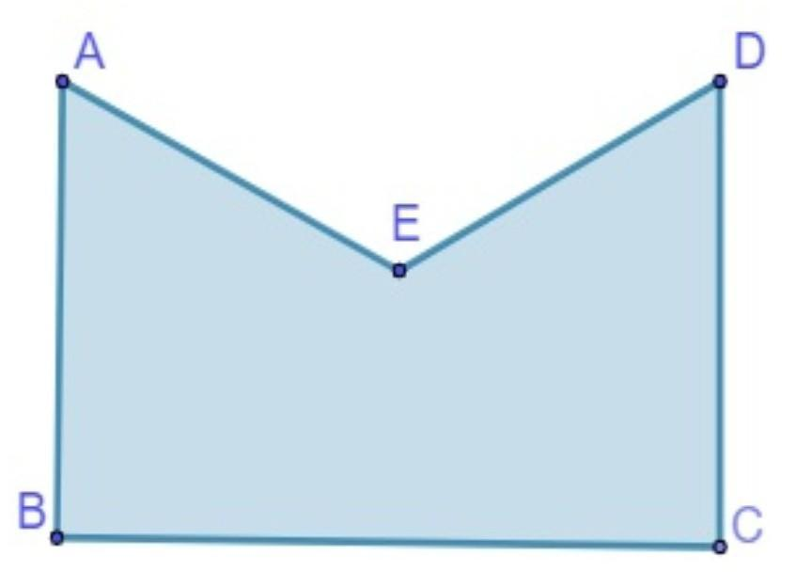
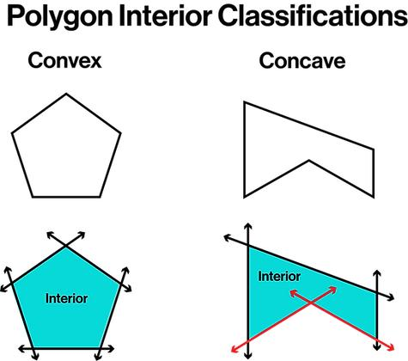
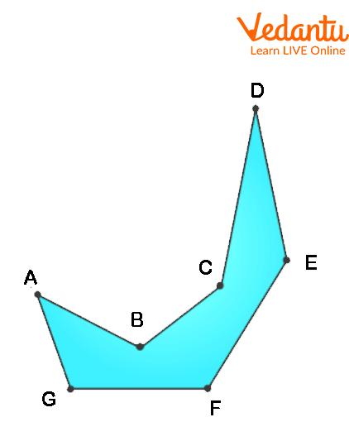
A Concave Polygonal Path can be used descriptively for a polygonal chain whose turns create an inward-bending configuration.
For a closed polygon, the standard term is concave polygon.
Example
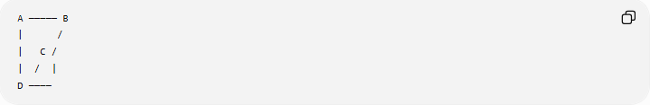
A ───── B
| /
| C /
| / |
D ────
The path contains an inward portion.
Important Note
For rigorous classification of closed polygonal figures, use:
- Convex polygon
- Concave polygon
- Self-intersecting polygon
rather than treating "convex path" and "concave path" as universal formal categories.

7. Regular Polygonal Path
# Source: AI Source: Provided by: [Data Path: Persons Table -> ID Column: 1, Name_En Column: Motasem Essam] -> From: [ChatGPT] on [7/25/2026]
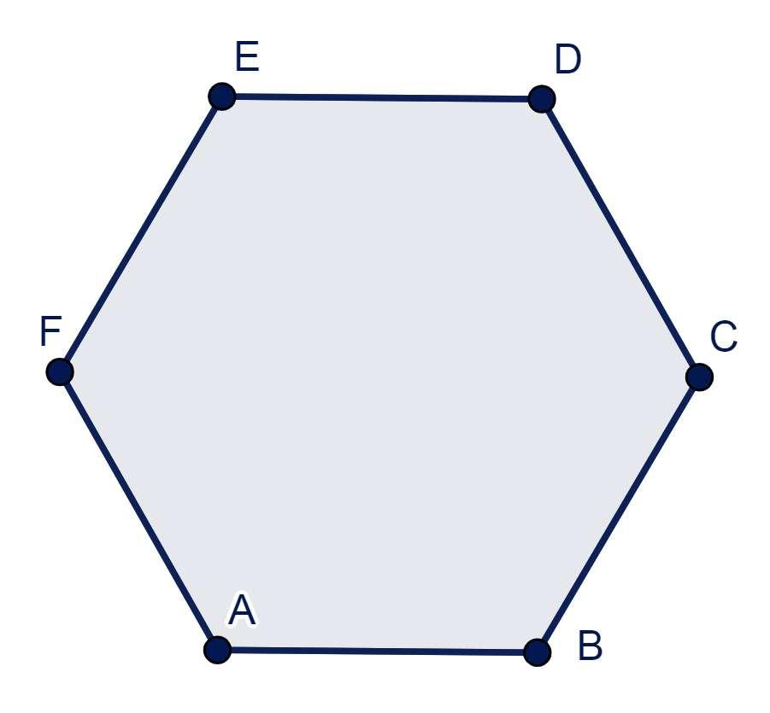
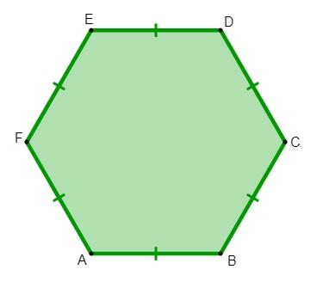
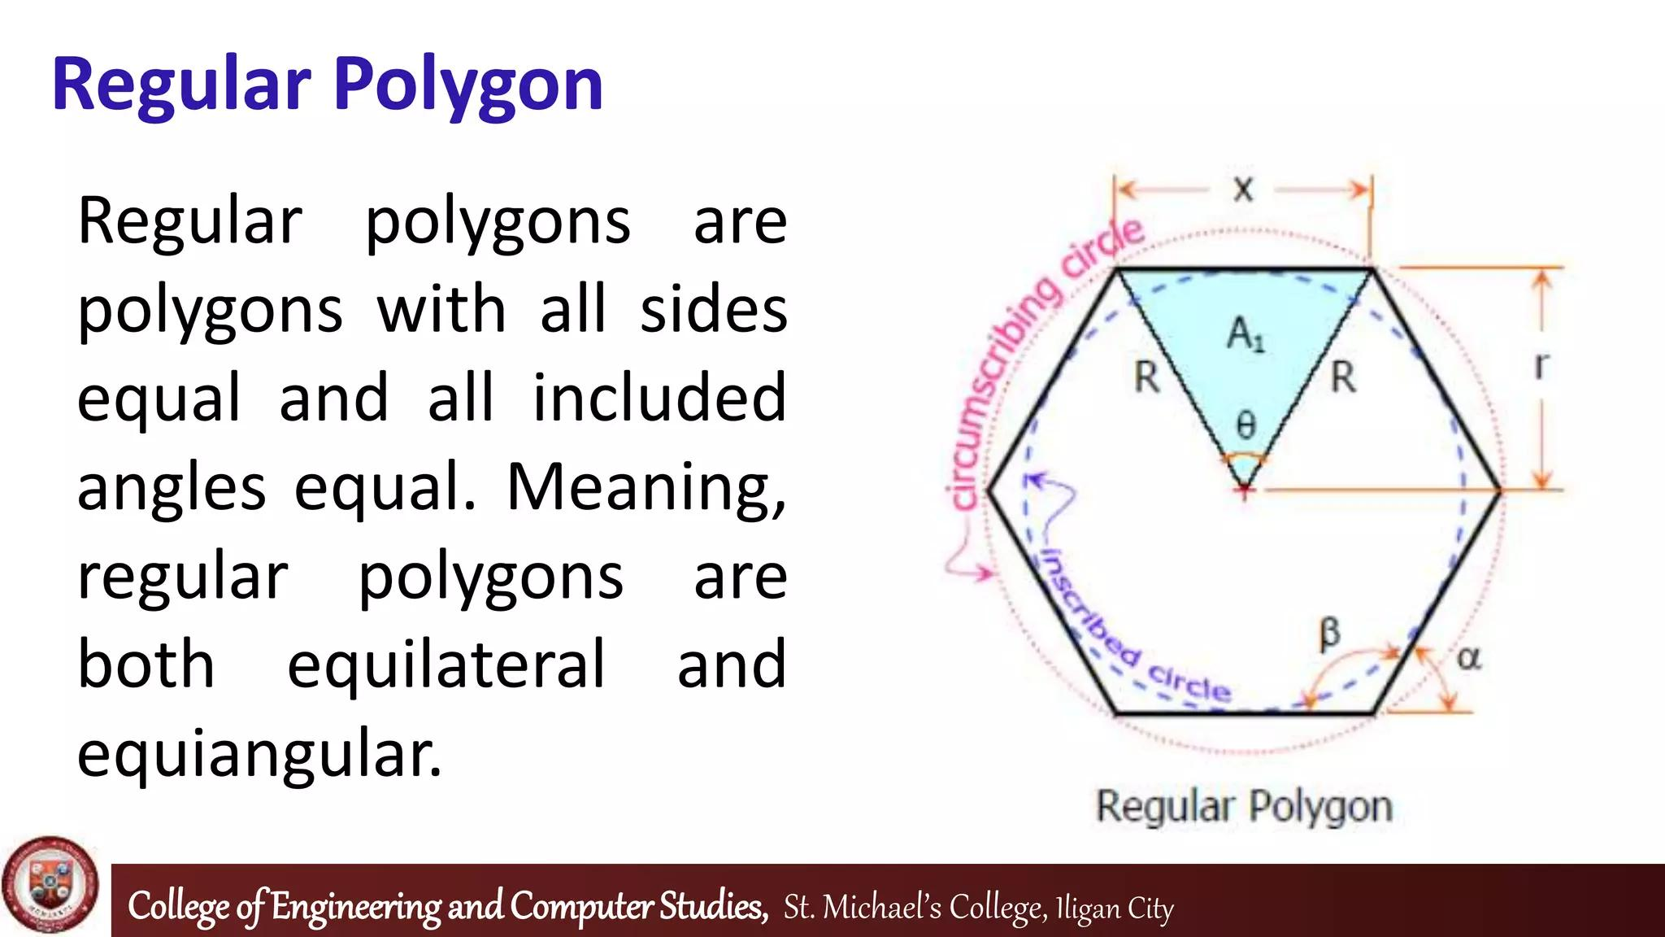
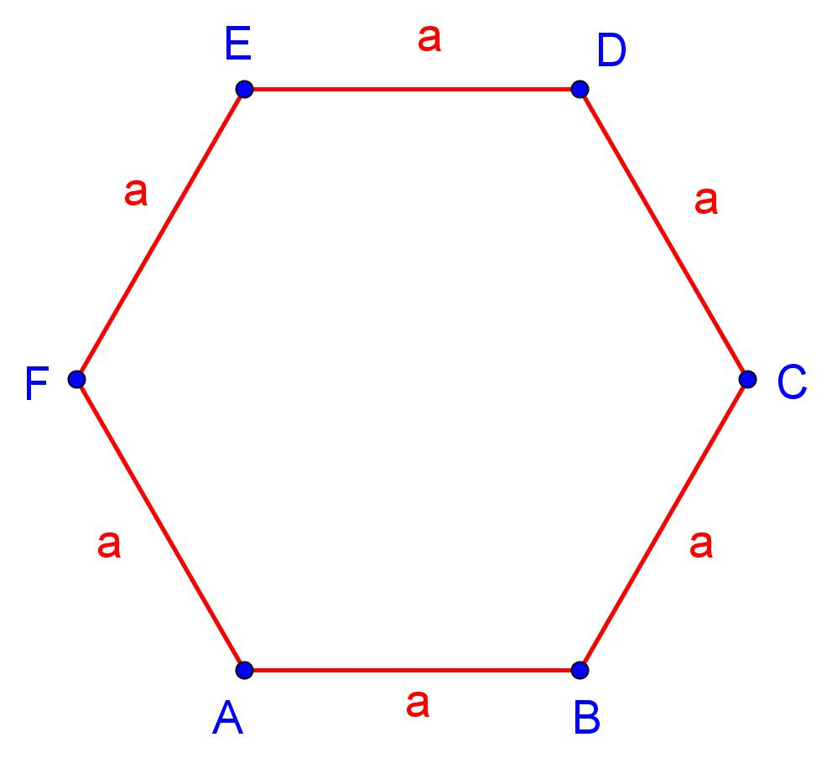
A Regular Polygonal Path can be used to describe a polygonal path whose segments form a regular polygonal structure.
For a closed path forming a regular $n$-gon:
$$\boxed{\text{All sides are equal}}$$
and
$$\boxed{\text{All interior angles are equal}}$$
Example
A regular hexagonal path:
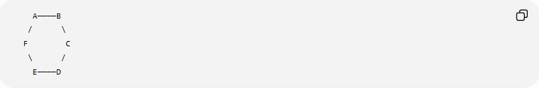
A────B
/ \
F C
\ /
E────D
For a regular hexagon:
$$AB=BC=CD=DE=EF=FA$$
and every interior angle is
$${120}^{∘}.$$
Important
For an open path, "regular" is descriptive rather than a universally standardized classification.

8. Irregular Polygonal Path
# Source: AI Source: Provided by: [Data Path: Persons Table -> ID Column: 1, Name_En Column: Motasem Essam] -> From: [ChatGPT] on [7/25/2026]
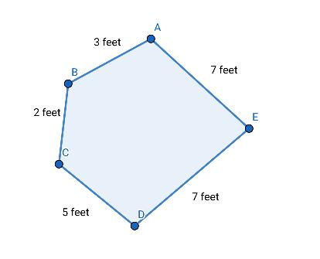
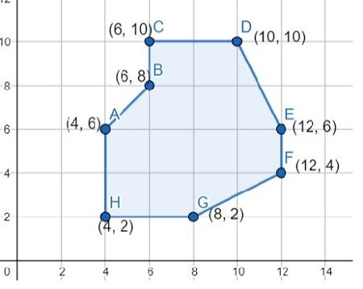
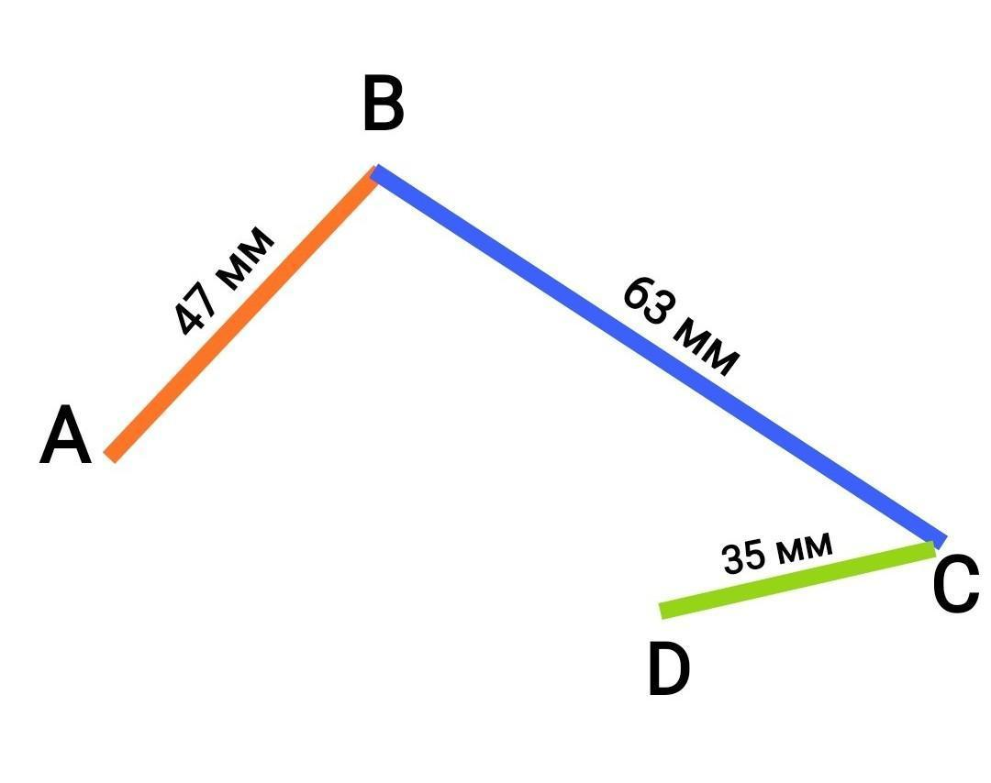
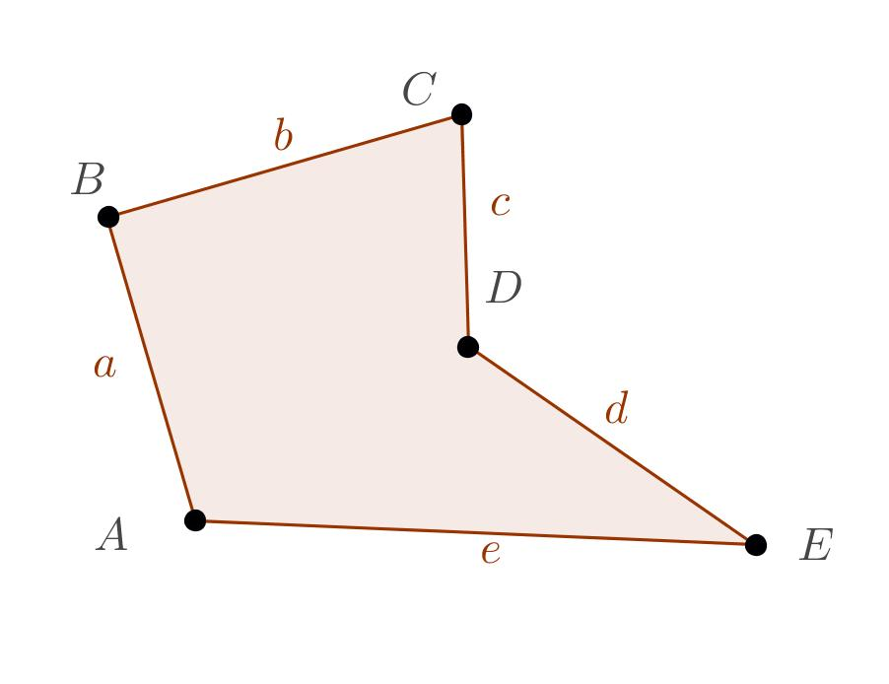
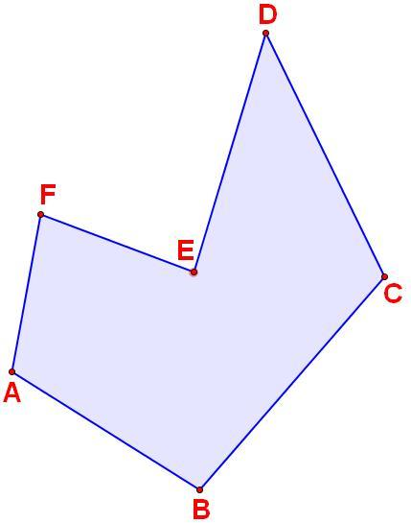
An Irregular Polygonal Path is a polygonal path whose segments or angles do not satisfy the equal-length/equal-angle requirements of a regular polygon.
Example
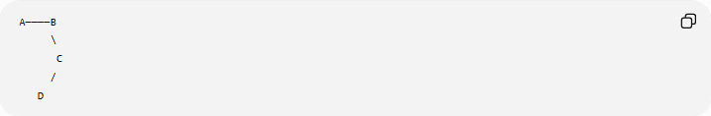
A────B
\
C
/
D
The segment lengths and turning angles may all be different.
Important
Irregular does not mean random or self-intersecting.
An irregular polygonal path can still be simple and well organized.

9. Equilateral Polygonal Path
# Source: AI Source: Provided by: [Data Path: Persons Table -> ID Column: 1, Name_En Column: Motasem Essam] -> From: [ChatGPT] on [7/25/2026]
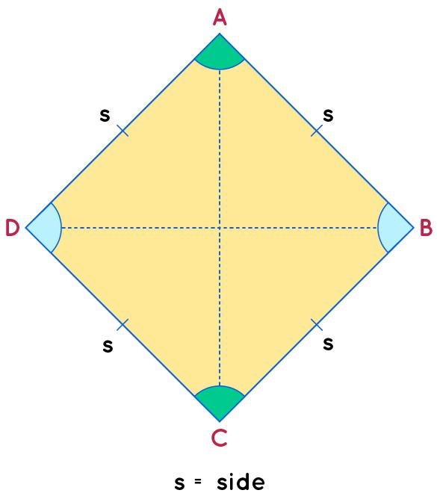
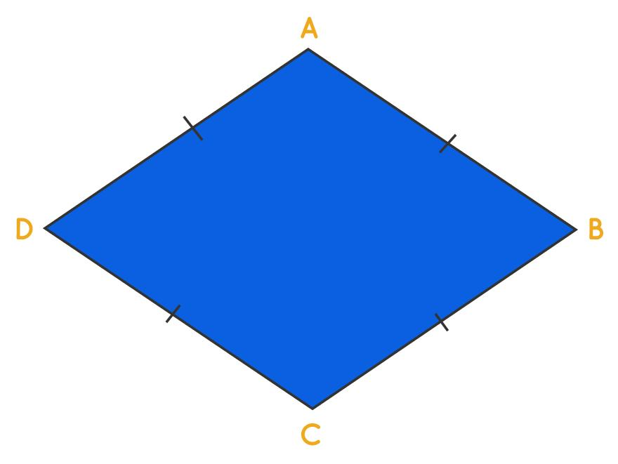
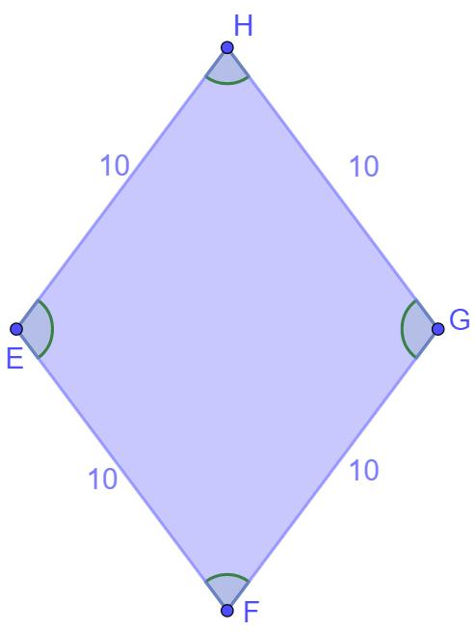
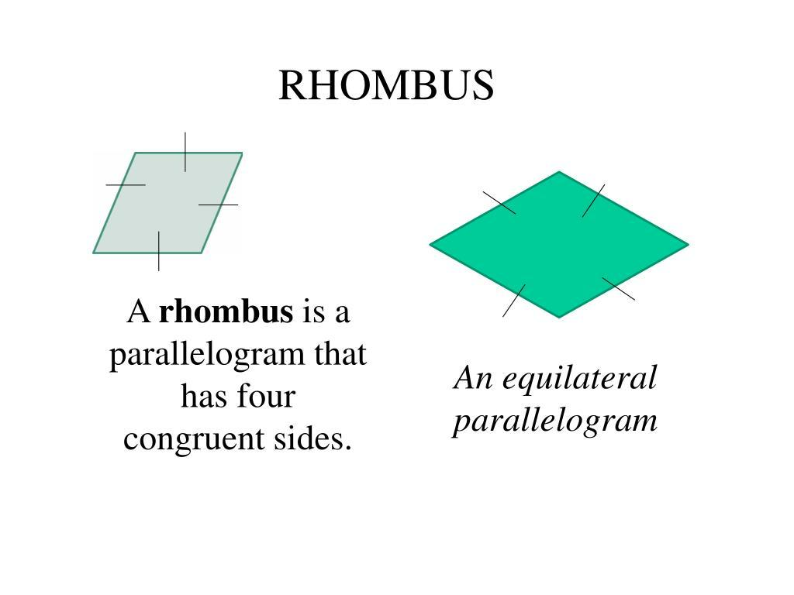
Definition
An Equilateral Polygonal Path has equal-length segments.
For a closed $n$-segment path:
$$\boxed{P_{0}P_{1}=P_{1}P_{2}=⋯=P_{n-1}P_{n}}$$
Example
A rhombus is an equilateral polygon:
$$AB=BC=CD=DA$$
Important
Equal side lengths do not necessarily mean equal angles.
Therefore:
$$\boxed{\text{Equilateral}≠\text{Regular}}$$
A rhombus can be equilateral without being regular.

10. Equiangular Polygonal Path
# Source: AI Source: Provided by: [Data Path: Persons Table -> ID Column: 1, Name_En Column: Motasem Essam] -> From: [ChatGPT] on [7/25/2026]
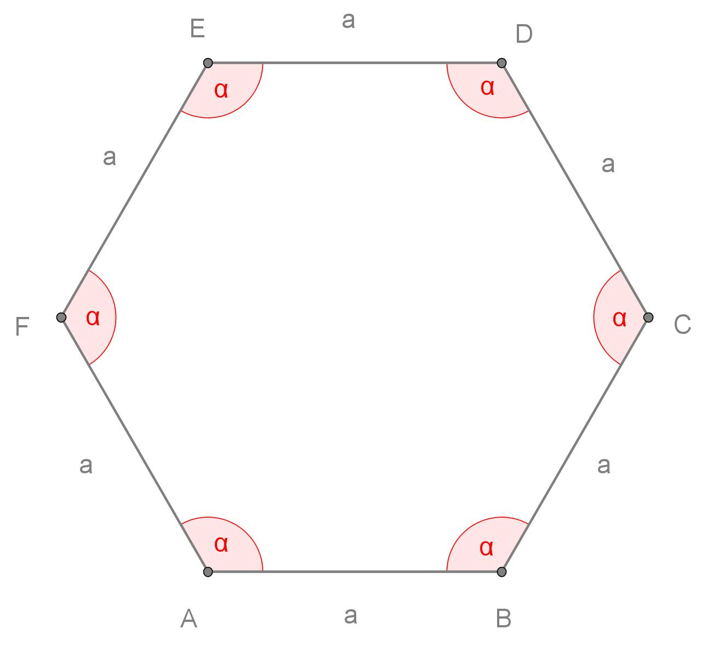
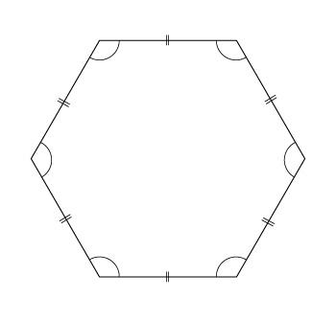
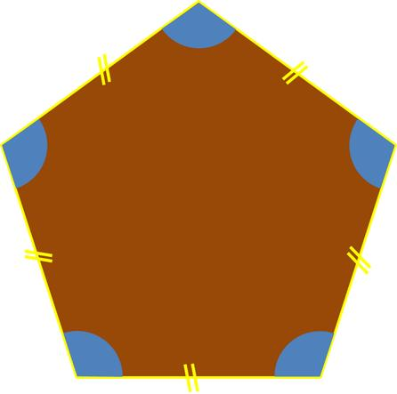
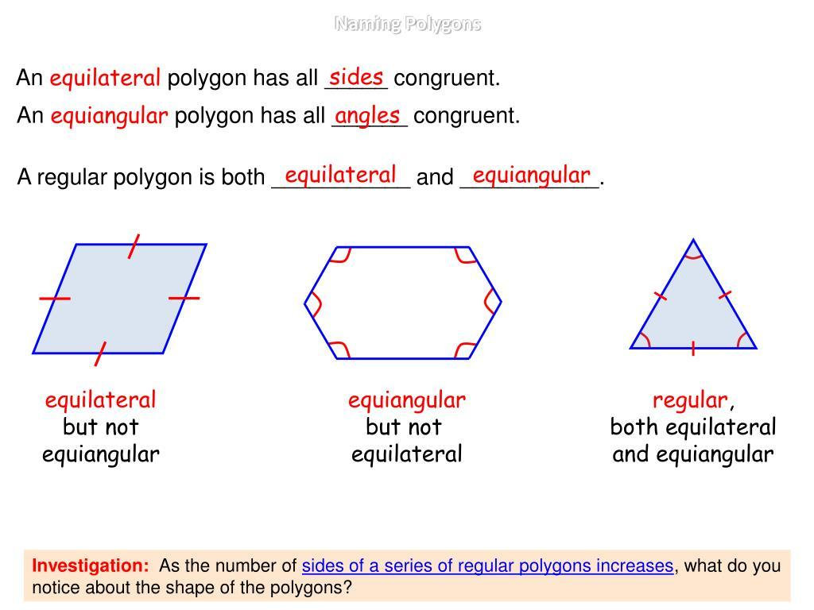
Definition
An Equiangular Polygonal Path has equal turning or interior angles, depending on whether the path is open or closed.
For a regular $n$-gon, each interior angle is:
$$\boxed{\frac{\left(n-2\right){180}^{∘}}{n}}$$
Example
For a regular hexagon:
$$\frac{\left(6-2\right){180}^{∘}}{6}={120}^{∘}$$
So every interior angle is ${120}^{∘}$.
Important
Equal angles alone do not necessarily imply equal side lengths.

11. Monotone Polygonal Path
# Source: AI Source: Provided by: [Data Path: Persons Table -> ID Column: 1, Name_En Column: Motasem Essam] -> From: [ChatGPT] on [7/25/2026]
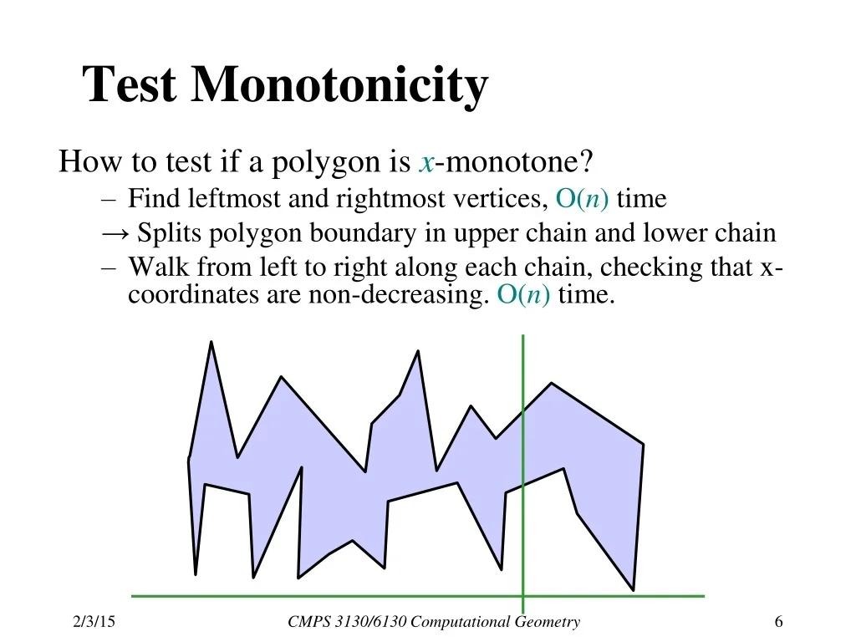
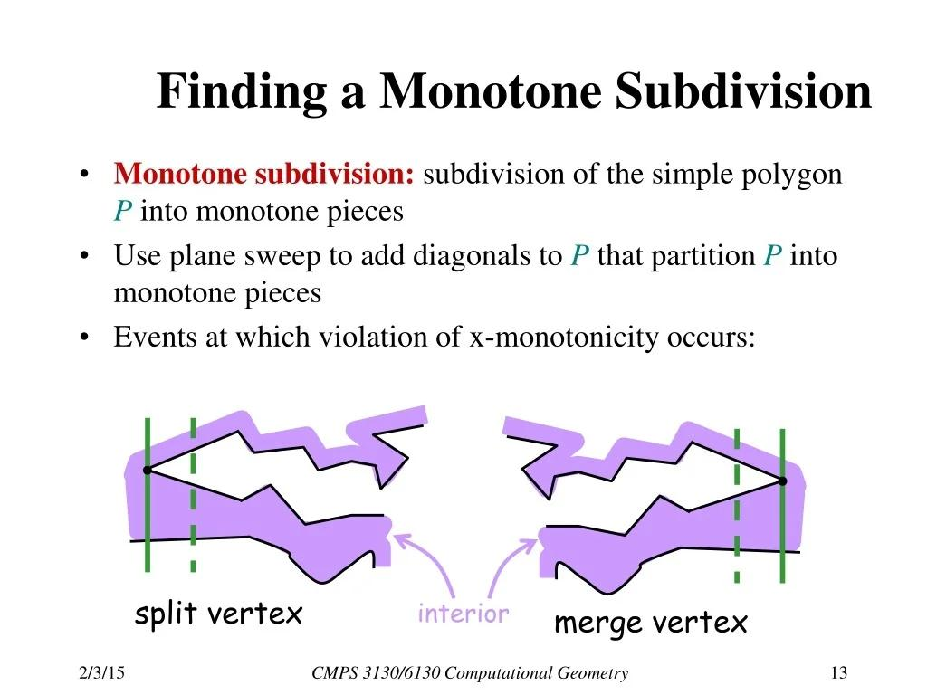
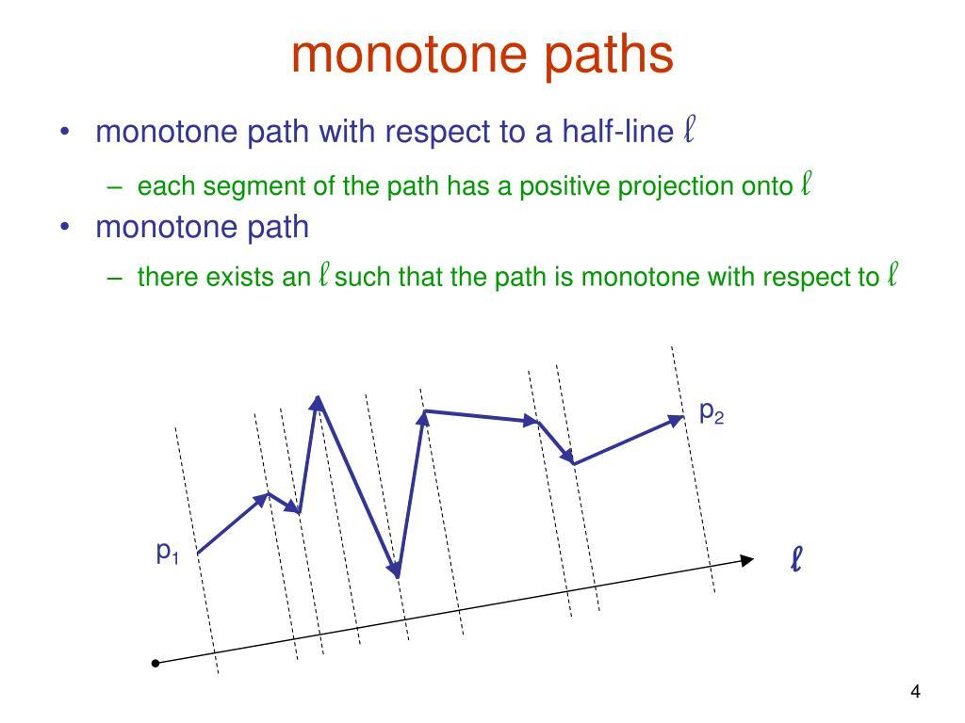
Definition
A Monotone Polygonal Path is a polygonal path that progresses consistently in a specified coordinate direction.
For example, an $x$-monotone path does not reverse its overall horizontal progression.
Example
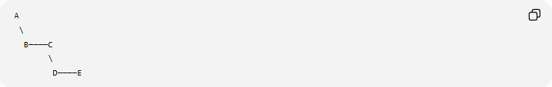
A
\
B────C
\
D────E
The path continuously progresses from left to right.
Mathematical Idea
For an $x$-monotone path, every vertical line intersects the path in at most one connected portion under the usual definition.
Similarly, a $y$-monotone path has consistent vertical progression.

12. Orthogonal Polygonal Path
# Source: AI Source: Provided by: [Data Path: Persons Table -> ID Column: 1, Name_En Column: Motasem Essam] -> From: [ChatGPT] on [7/25/2026]
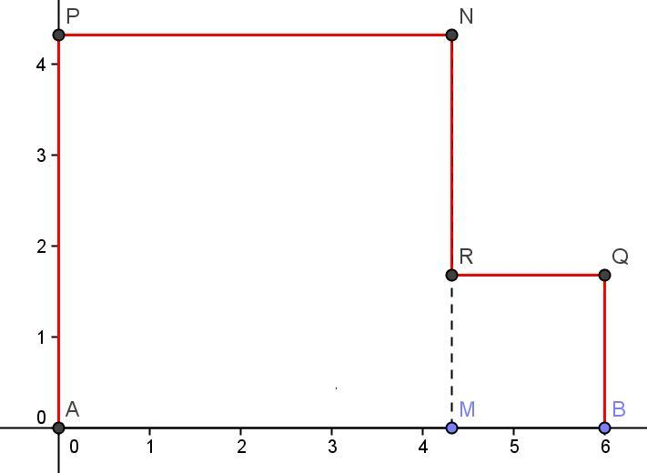
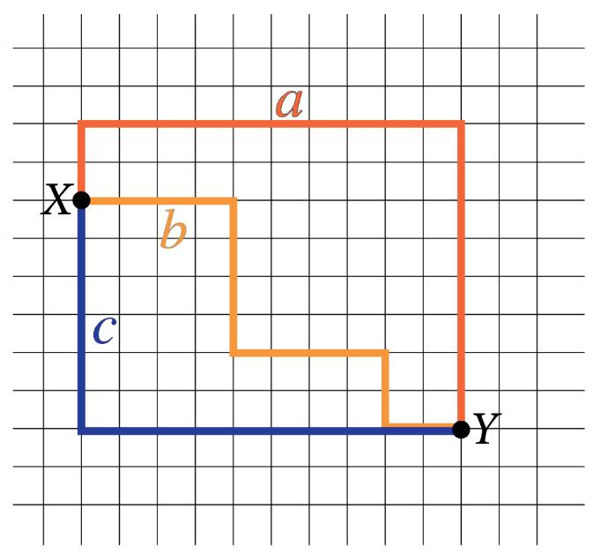
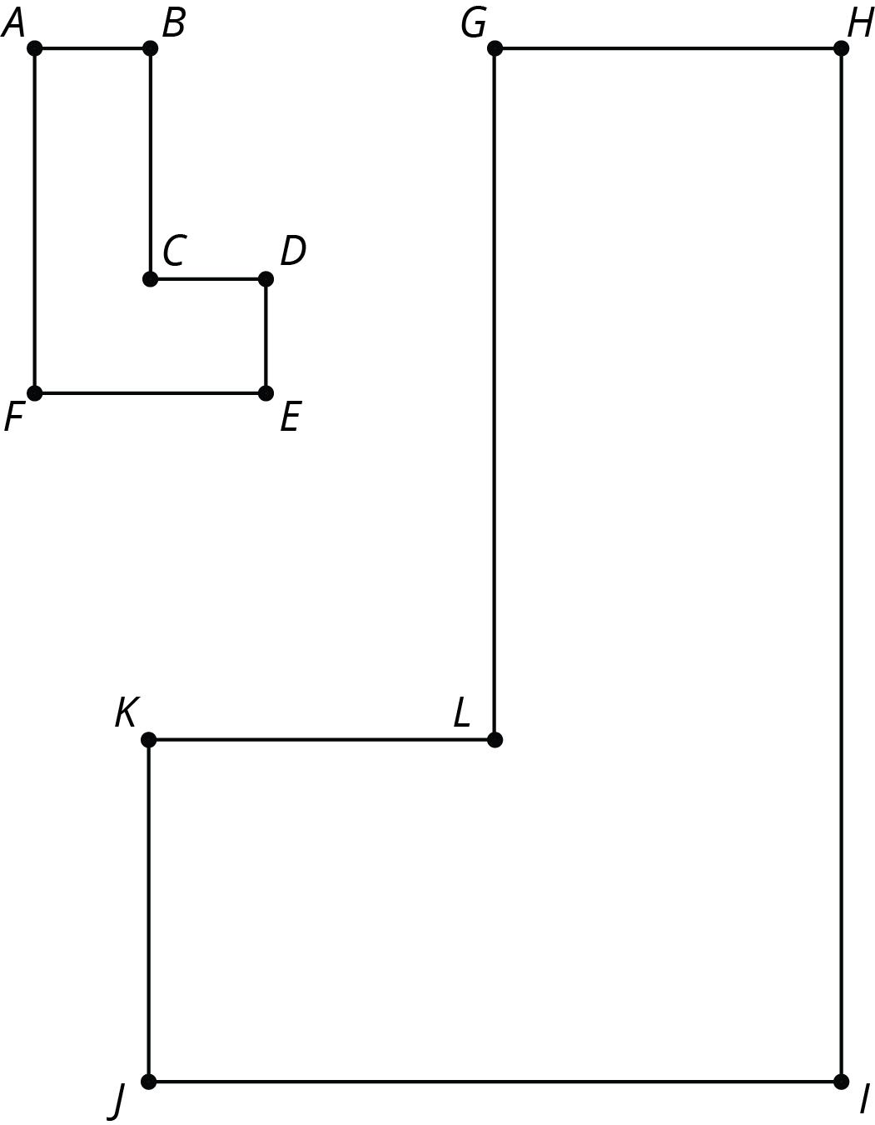
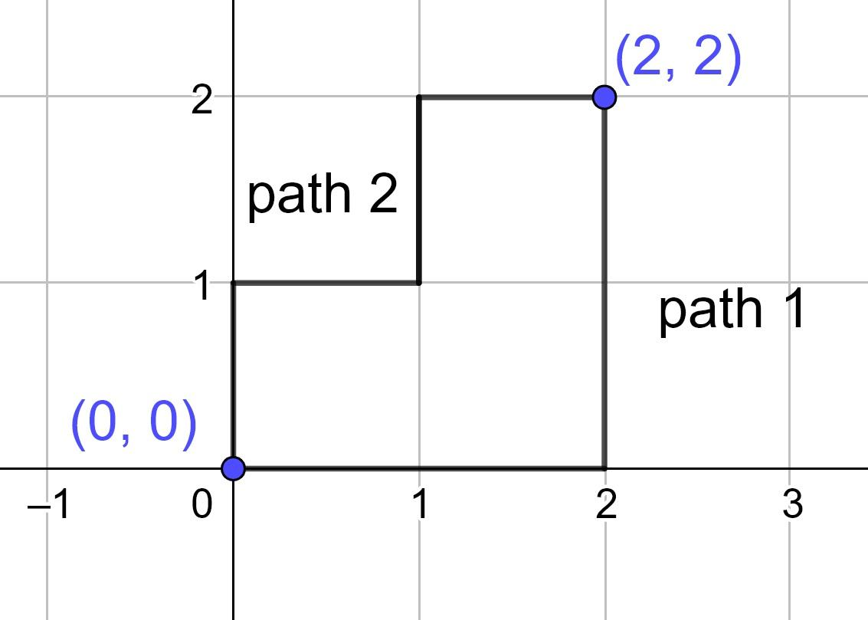
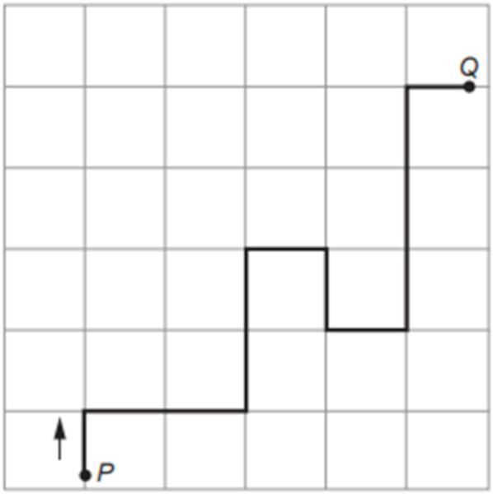
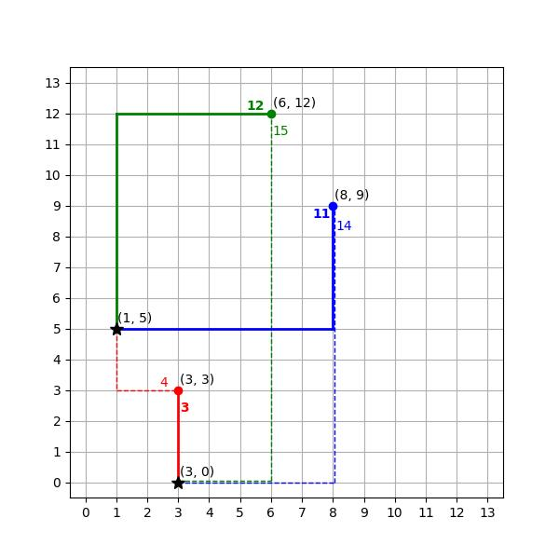
Definition
An Orthogonal Polygonal Path consists entirely of horizontal and vertical segments.
Thus every segment is parallel to one of the coordinate axes.
Example
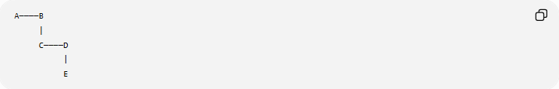
A────B
|
C────D
|
E
Every segment is either:
$$\text{horizontal}$$
or
$$\text{vertical}.$$
Coordinate Condition
For horizontal segments:
$$y_{1}=y_{2}$$
For vertical segments:
$$x_{1}=x_{2}$$
Important
A closed simple orthogonal polygon has interior angles of either:
$${90}^{∘}$$
or
$${270}^{∘}.$$

13. Zigzag Polygonal Path
# Source: AI Source: Provided by: [Data Path: Persons Table -> ID Column: 1, Name_En Column: Motasem Essam] -> From: [ChatGPT] on [7/25/2026]
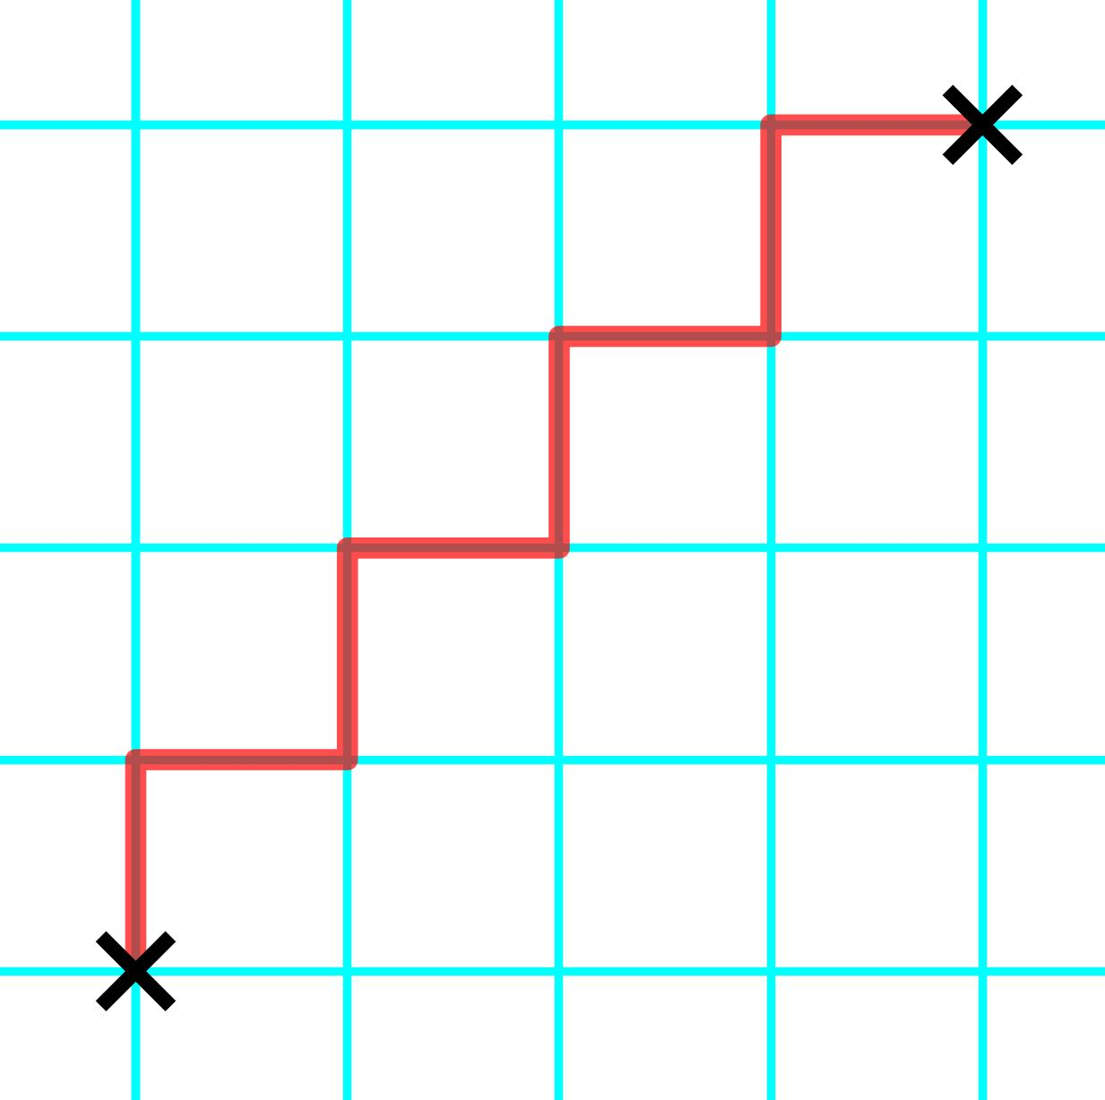
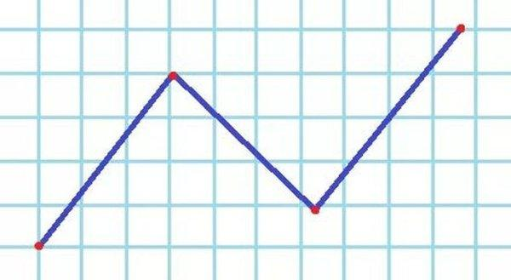
Definition
A Zigzag Polygonal Path is a polygonal path that repeatedly changes its direction, producing a back-and-forth pattern.
Example
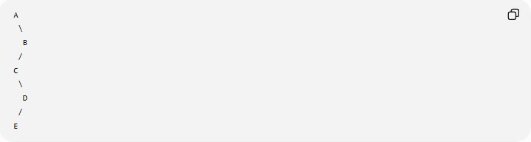
A
\
B
/
C
\
D
/
E
The path alternates between directions.
Applications
Zigzag paths can appear in:
- geometric algorithms
- computer graphics
- route planning
- pattern construction
- approximating curves.

14. Star-Shaped Polygonal Path
# Source: AI Source: Provided by: [Data Path: Persons Table -> ID Column: 1, Name_En Column: Motasem Essam] -> From: [ChatGPT] on [7/25/2026]
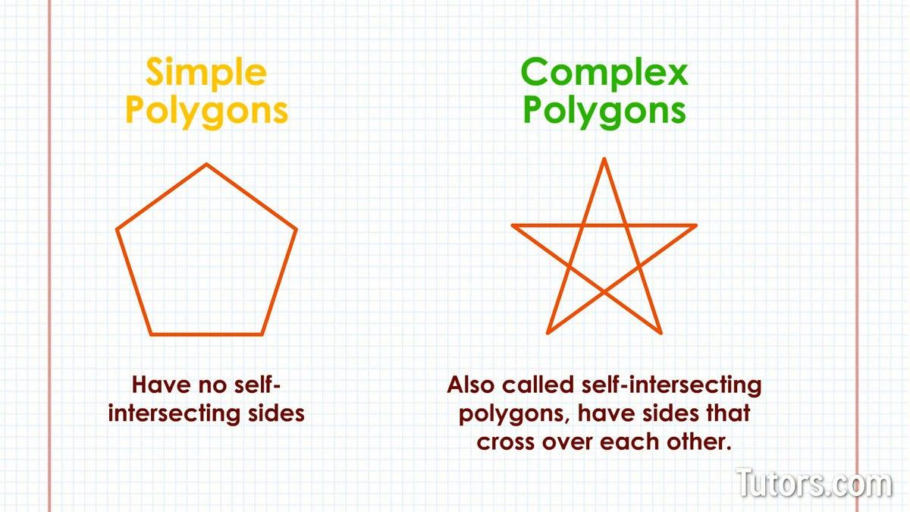
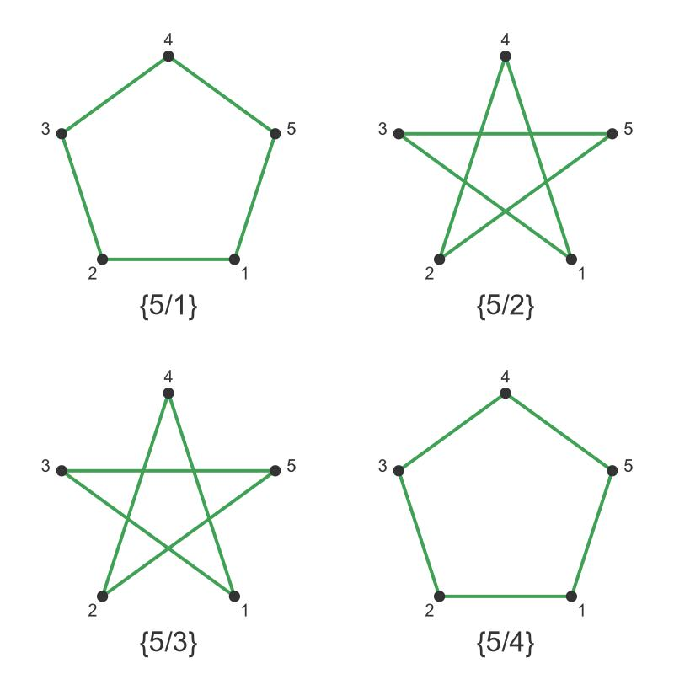
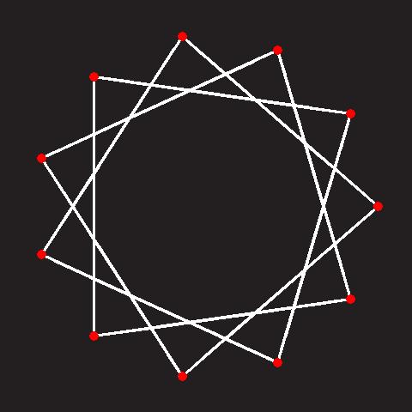
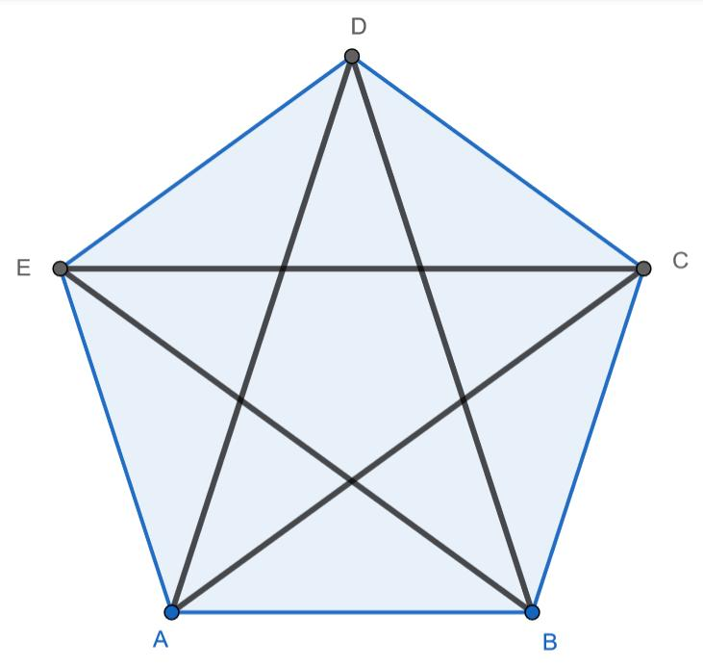
Definition
A Star-Shaped Polygonal Path is a descriptive term for a polygonal path arranged in a star-like configuration.
A closed version may form a star polygon.
Example
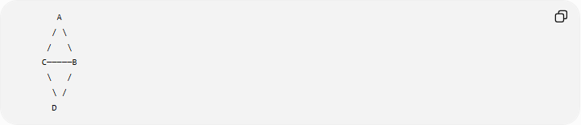
A
/ \
/ \
C─────B
\ /
\ /
D
A more complex star polygon can contain self-intersections.
Important
A star-shaped region and a star polygon are not the same concept.
"Star-shaped" should therefore be used carefully.

15. Piecewise-Linear Path
# Source: AI Source: Provided by: [Data Path: Persons Table -> ID Column: 1, Name_En Column: Motasem Essam] -> From: [ChatGPT] on [7/25/2026]
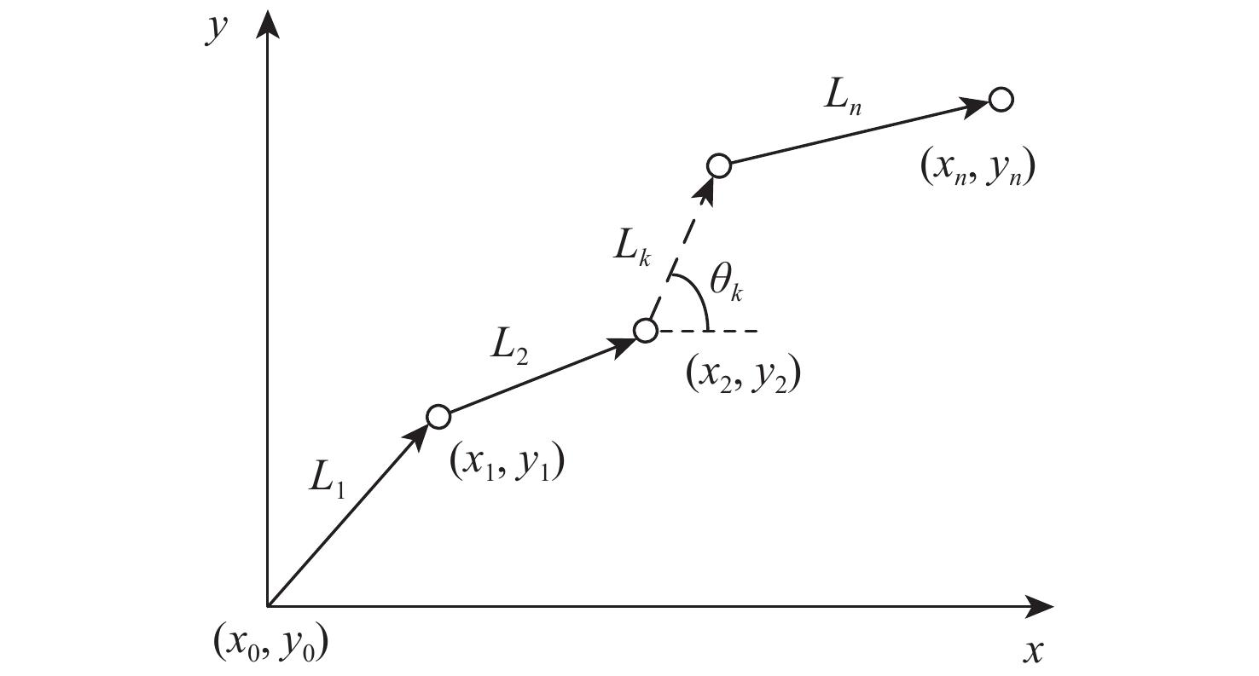
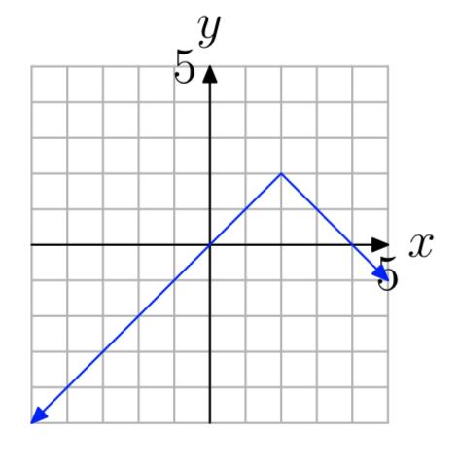
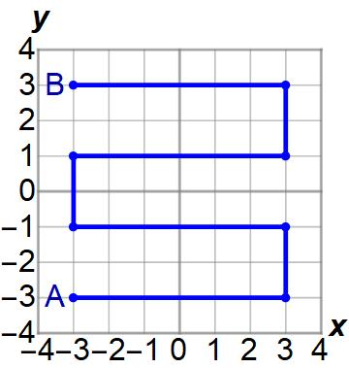
Definition
A Piecewise-Linear Path is a path composed of multiple linear pieces joined at vertices.
This is one of the most general and mathematically precise descriptions of a polygonal path.
$$\boxed{\text{Polygonal Path}=\text{Piecewise-Linear Path}}$$
in the usual geometric sense.
Example
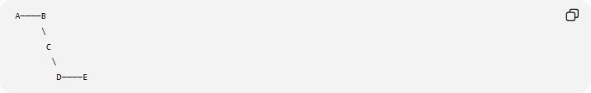
A────B
\
C
\
D────E
Each individual portion is a straight segment, but the entire path changes direction at vertices.
Mathematical Representation
$$P\left(t\right)=\left\{\begin{matrix}P_{0}+λ_{1}\left(t\right)\left(P_{1}-P_{0}\right), \\ P_{1}+λ_{2}\left(t\right)\left(P_{2}-P_{1}\right), \\ ⋮ \\ P_{n-1}+λ_{n}\left(t\right)\left(P_{n}-P_{n-1}\right)\end{matrix}\right.$$
with each piece corresponding to one segment.

16. Coordinate Polygonal Path
# Source: AI Source: Provided by: [Data Path: Persons Table -> ID Column: 1, Name_En Column: Motasem Essam] -> From: [ChatGPT] on [7/25/2026]
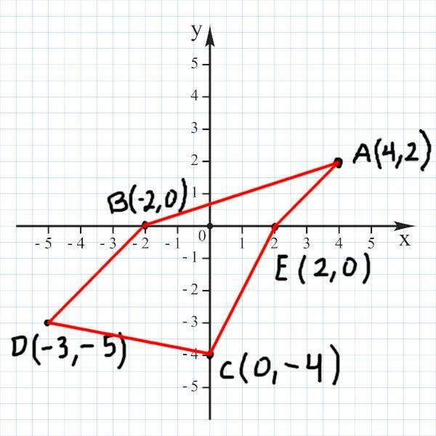
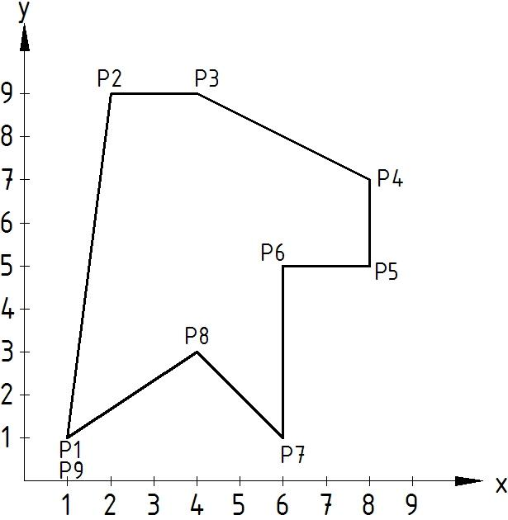
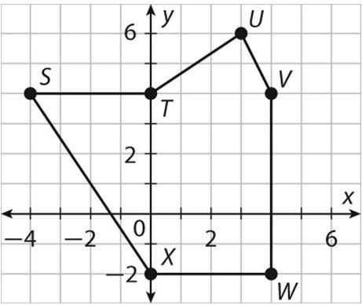
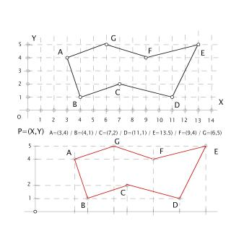
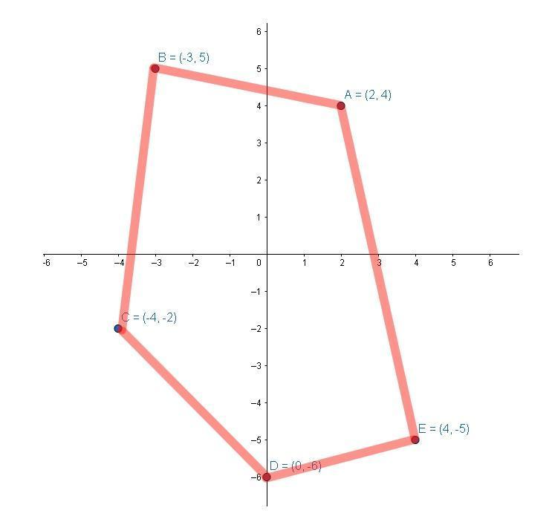
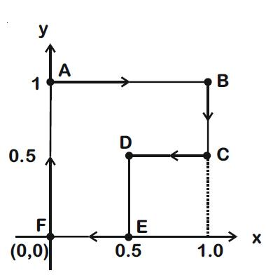
Definition
A Coordinate Polygonal Path is a polygonal path defined using points with coordinates.
For example:
$$A=\left(0 , 0\right) \\ B=\left(4 , 2\right) \\ C=\left(7 , 6\right) \\ D=\left(10 , 3\right)$$
The path is:
$$A→B→C→D.$$
Segment Length
For consecutive points
$$P_{i}=\left(x_{i} , y_{i}\right)$$
and
$$P_{i+1}=\left(x_{i+1} , y_{i+1}\right),$$
the segment length is:
$$\boxed{L_{i}=\sqrt{{\left(x_{i+1}-x_{i}\right)}^{2}+{\left(y_{i+1}-y_{i}\right)}^{2}}}$$

17. Parametric Polygonal Path
# Source: AI Source: Provided by: [Data Path: Persons Table -> ID Column: 1, Name_En Column: Motasem Essam] -> From: [ChatGPT] on [7/25/2026]
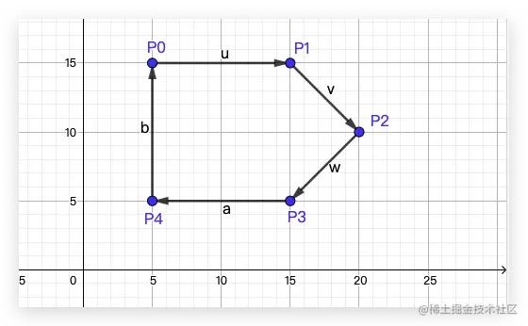
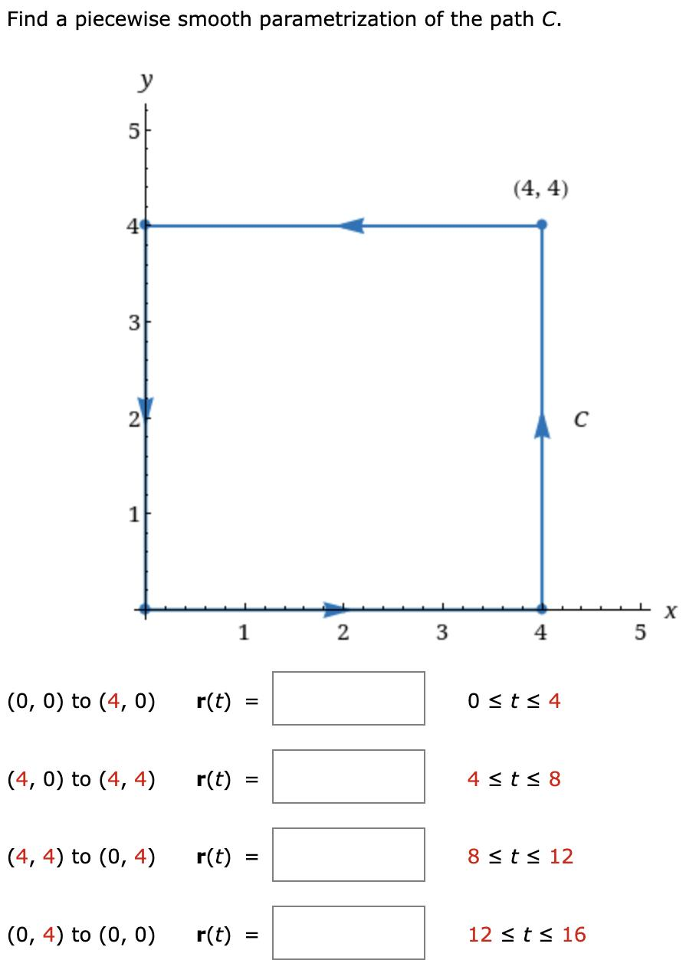
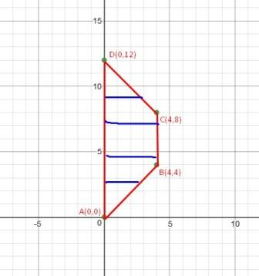
Definition
A Parametric Polygonal Path represents each segment using a parameter.
For a segment from $A$to $B$:
$$\boxed{r\left(t\right)=A+t\left(B-A\right)}$$
where
$$0≤t≤1.$$
Example
For
$$A=\left(1 , 2\right), B=\left(5 , 6\right),$$
we obtain:
$$r\left(t\right)=\left(1 , 2\right)+t\left(4 , 4\right).$$
Therefore:
$$x=1+4t \\ y=2+4t.$$
At $t=0$:
$$P=A$$
and at $t=1$:
$$P=B.$$
A complete polygonal path is obtained by applying this representation to each consecutive pair of vertices.

18. Vector-Defined Polygonal Path
# Source: AI Source: Provided by: [Data Path: Persons Table -> ID Column: 1, Name_En Column: Motasem Essam] -> From: [ChatGPT] on [7/25/2026]
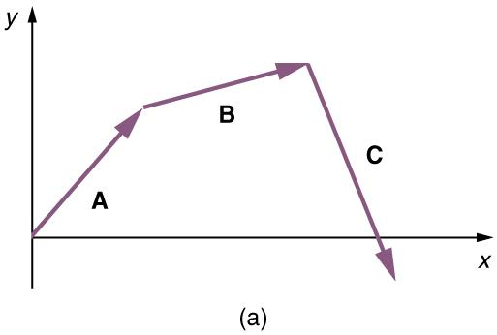
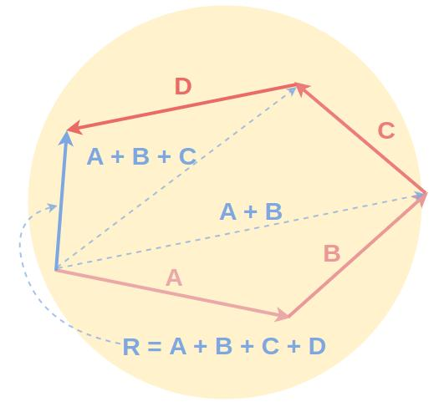
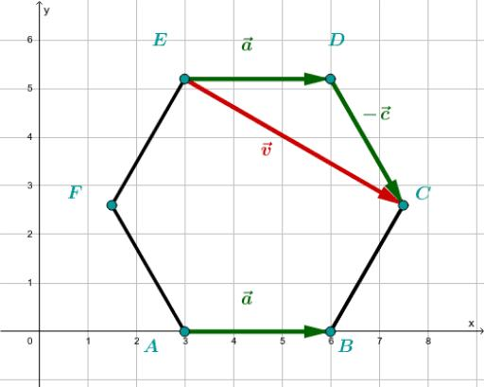
A polygonal path can also be represented using vectors.
For vertices:
$$P_{0},P_{1},…,P_{n},$$
the displacement vectors are:
$$\boxed{{\vec{v}}_{i}=\vec{P_{i}P_{i+1}}}$$
and the path is obtained by connecting these vectors sequentially.
Example
If:
$$A=\left(0 , 0\right), B=\left(3 , 1\right), C=\left(5 , 4\right),$$
then:
$$\vec{AB}=\left(3 , 1\right)$$
and
$$\vec{BC}=\left(2 , 3\right).$$
The polygonal path is constructed from these consecutive displacement vectors.

19. Restricted Polygonal Path
# Source: AI Source: Provided by: [Data Path: Persons Table -> ID Column: 1, Name_En Column: Motasem Essam] -> From: [ChatGPT] on [7/25/2026]
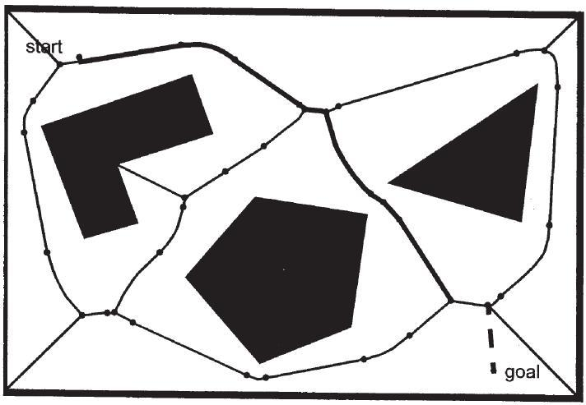
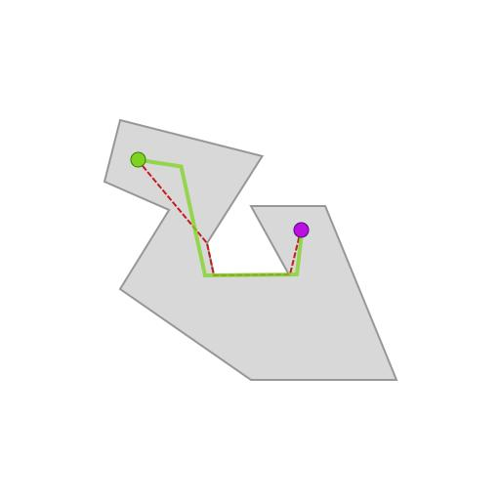
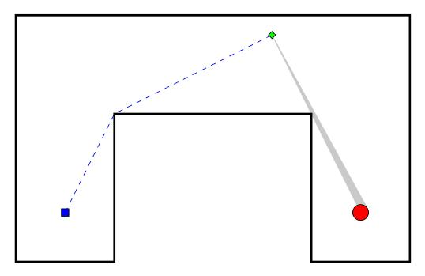
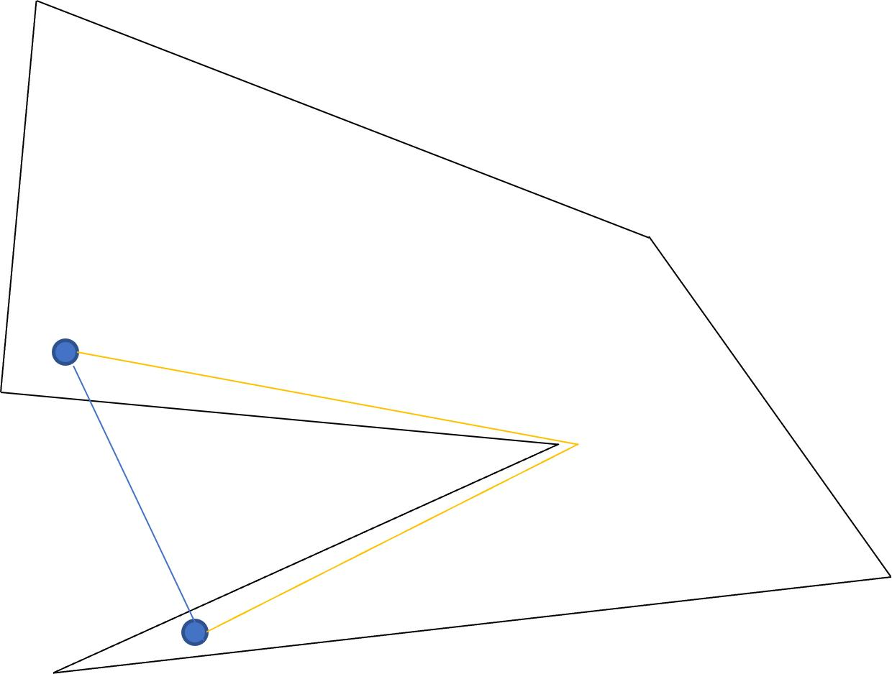
Definition
A Restricted Polygonal Path is a polygonal path limited by additional geometric conditions.
For example:
- restricted to a region
- restricted to a segment
- restricted to certain vertices
- restricted to avoid obstacles
- restricted to a coordinate area.
Example
Suppose:
$$P∈R$$
where $R$is a rectangular region.
The polygonal path must remain inside $R$.
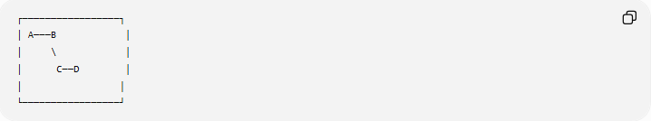
┌─────────────────┐
│ A───B │
│ \ │
│ C──D │
│ │
└─────────────────┘

20. Convex-Chain Path
# Source: AI Source: Provided by: [Data Path: Persons Table -> ID Column: 1, Name_En Column: Motasem Essam] -> From: [ChatGPT] on [7/25/2026]
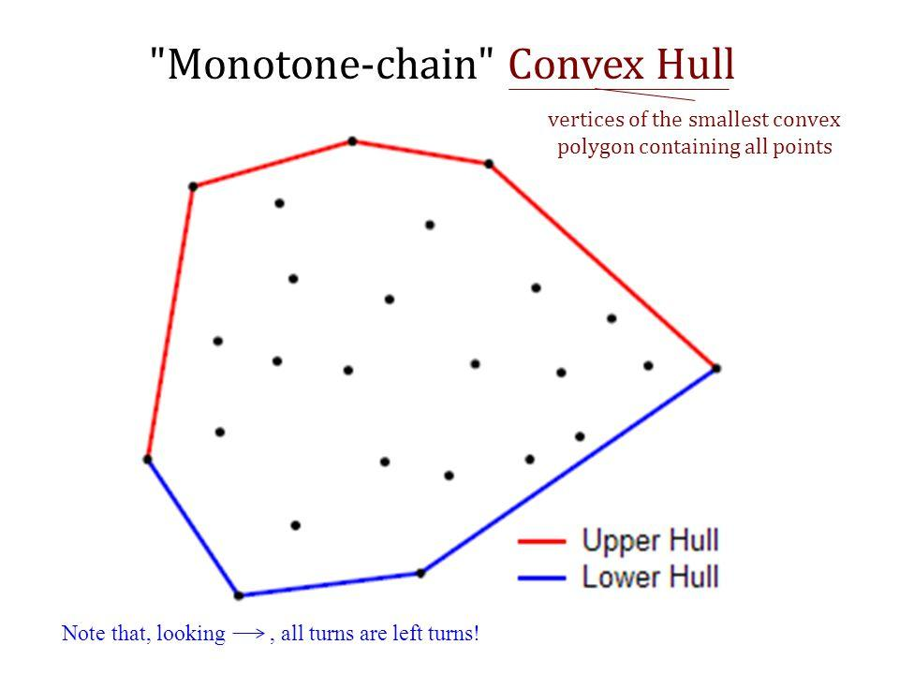
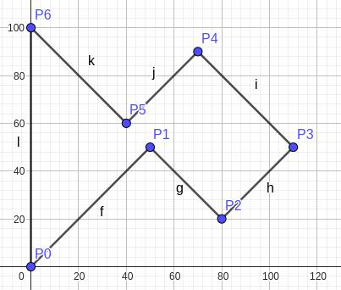
Definition
A Convex Chain is a polygonal chain whose turns are consistently oriented so that the chain behaves as part of the boundary of a convex region.
Example

A
\
B
\
C
\
D
The direction continuously turns in the same sense.
Application
Convex chains are important in:
- computational geometry
- convex hulls
- shortest-path algorithms
- visibility problems.

21. Combined Polygonal Path
# Source: AI Source: Provided by: [Data Path: Persons Table -> ID Column: 1, Name_En Column: Motasem Essam] -> From: [ChatGPT] on [7/25/2026]
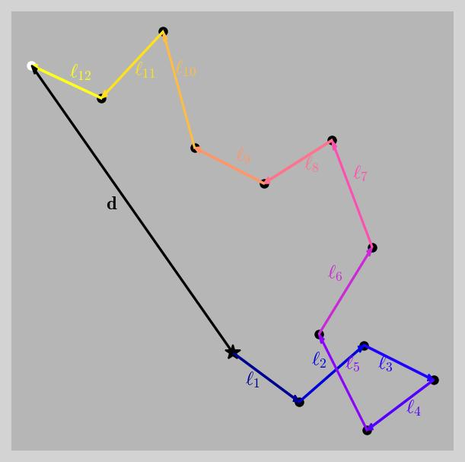
Definition
A Combined Polygonal Path is a path that contains polygonal segments together with other types of geometric paths.
For example:
$$\boxed{\text{Straight Segment}→\text{Circular Arc}→\text{Straight Segment}}$$
Example
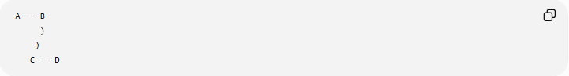
A────B
)
)
C────D
The first and last portions are straight, while the middle portion is curved.
Important
Such a path is not purely polygonal, because a polygonal path consists entirely of line segments.

Total Length of a Polygonal Path
# Source: AI Source: Provided by: [Data Path: Persons Table -> ID Column: 1, Name_En Column: Motasem Essam] -> From: [ChatGPT] on [7/25/2026]
If the path contains vertices
$$P_{0},P_{1},…,P_{n},$$
its total length is:
$$\boxed{L=\sum_{i=0}^{n-1}{∣}P_{i}P_{i+1}∣}$$
In 2D:
$$\boxed{L=\sum_{i=0}^{n-1}{\sqrt{{\left(x_{i+1}-x_{i}\right)}^{2}+{\left(y_{i+1}-y_{i}\right)}^{2}}}}$$
Example
Suppose:
$$A=\left(0 , 0\right), B=\left(3 , 0\right), C=\left(3 , 4\right).$$
Then:
$$AB=3$$
and
$$BC=4.$$
Therefore:
$$\boxed{L=3+4=7}$$

Polygonal Path and Shortest Distance
# Source: AI Source: Provided by: [Data Path: Persons Table -> ID Column: 1, Name_En Column: Motasem Essam] -> From: [ChatGPT] on [7/25/2026]
For points $A$and $B$, any polygonal path connecting them has length at least the direct distance:
$$\boxed{L≥AB}$$
Equality occurs when the path is simply the straight segment:
$$\boxed{L=AB}$$
Example
For:
$$A=\left(0 , 0\right), B=\left(3 , 4\right),$$
the direct distance is:
$$AB=5.$$
A polygonal path
$$A→C→B$$
must have:
$$AC+CB≥5.$$
This is a repeated application of the triangle inequality.

Polygonal Path vs Polygon
# Source: AI Source: Provided by: [Data Path: Persons Table -> ID Column: 1, Name_En Column: Motasem Essam] -> From: [ChatGPT] on [7/25/2026]
These concepts should not be confused.
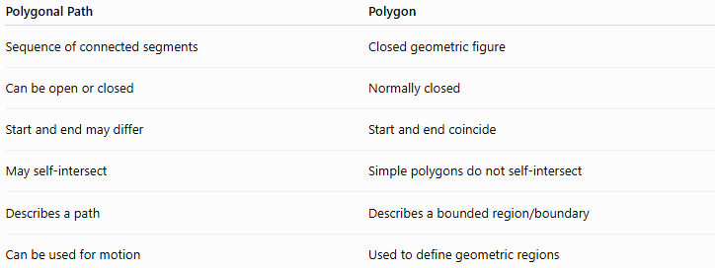
Polygonal Path | Polygon
Sequence of connected segments | Closed geometric figure
Can be open or closed | Normally closed
Start and end may differ | Start and end coincide
May self-intersect | Simple polygons do not self-intersect
Describes a path | Describes a bounded region/boundary
Can be used for motion | Used to define geometric regions
A closed simple polygonal path forms the boundary of a polygon.

Polygonal Path vs Straight-Line Path
# Source: AI Source: Provided by: [Data Path: Persons Table -> ID Column: 1, Name_En Column: Motasem Essam] -> From: [ChatGPT] on [7/25/2026]
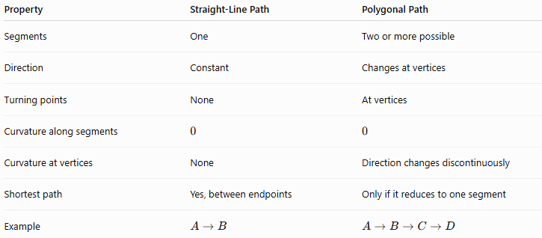
Property | Straight-Line Path | Polygonal Path
Segments | One | Two or more possible
Direction | Constant | Changes at vertices
Turning points | None | At vertices
Curvature along segments | $$0$$ | $$0$$
Curvature at vertices | None | Direction changes discontinuously
Shortest path | Yes, between endpoints | Only if it reduces to one segment
Example | $$A→B$$ | $$A→B→C→D$$
A polygonal path can therefore be considered a sequence of straight-line paths joined together.

Polygonal Path vs Circular Path
# Source: AI Source: Provided by: [Data Path: Persons Table -> ID Column: 1, Name_En Column: Motasem Essam] -> From: [ChatGPT] on [7/25/2026]
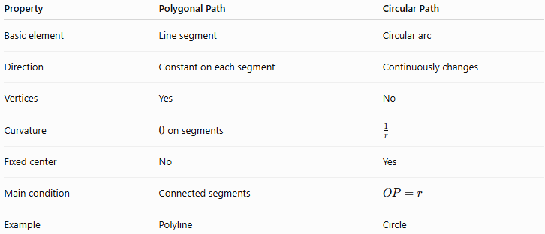
Property | Polygonal Path | Circular Path
Basic element | Line segment | Circular arc
Direction | Constant on each segment | Continuously changes
Vertices | Yes | No
Curvature | $0$on segments | $$\frac{1}{r}$$
Fixed center | No | Yes
Main condition | Connected segments | $$OP=r$$
Example | Polyline | Circle

Classification Summary
# Source: AI Source: Provided by: [Data Path: Persons Table -> ID Column: 1, Name_En Column: Motasem Essam] -> From: [ChatGPT] on [7/25/2026]
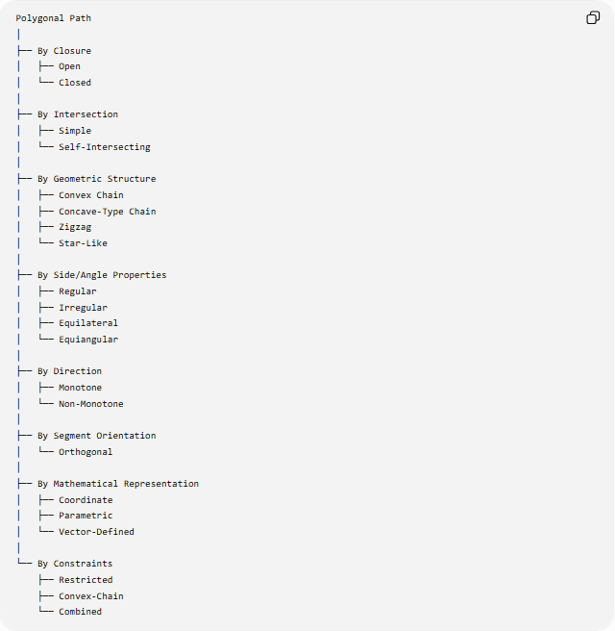
Polygonal Path
│
├── By Closure
│ ├── Open
│ └── Closed
│
├── By Intersection
│ ├── Simple
│ └── Self-Intersecting
│
├── By Geometric Structure
│ ├── Convex Chain
│ ├── Concave-Type Chain
│ ├── Zigzag
│ └── Star-Like
│
├── By Side/Angle Properties
│ ├── Regular
│ ├── Irregular
│ ├── Equilateral
│ └── Equiangular
│
├── By Direction
│ ├── Monotone
│ └── Non-Monotone
│
├── By Segment Orientation
│ └── Orthogonal
│
├── By Mathematical Representation
│ ├── Coordinate
│ ├── Parametric
│ └── Vector-Defined
│
└── By Constraints
├── Restricted
├── Convex-Chain
└── Combined

Key Formulas
# Source: AI Source: Provided by: [Data Path: Persons Table -> ID Column: 1, Name_En Column: Motasem Essam] -> From: [ChatGPT] on [7/25/2026]
Segment Length
$$\boxed{∣P_{i}P_{i+1}∣=\sqrt{{\left(x_{i+1}-x_{i}\right)}^{2}+{\left(y_{i+1}-y_{i}\right)}^{2}}}$$
Total Polygonal Path Length
$$\boxed{L=\sum_{i=0}^{n-1}{∣}P_{i}P_{i+1}∣}$$
Straight Segment Parameterization
$$\boxed{r\left(t\right)=P_{i}+t\left(P_{i+1}-P_{i}\right)} \\ 0≤t≤1$$
Shortest-Path Inequality
$$\boxed{L≥AB}$$
Equality Condition
$$\boxed{L=AB}$$
only when the polygonal path follows the direct straight segment from $A$to $B$.
Orthogonal Segment Conditions
Horizontal:
$$\boxed{y_{1}=y_{2}}$$
Vertical:
$$\boxed{x_{1}=x_{2}}$$

Key Points
# Source: AI Source: Provided by: [Data Path: Persons Table -> ID Column: 1, Name_En Column: Motasem Essam] -> From: [ChatGPT] on [7/25/2026]
- A polygonal path consists entirely of connected straight-line segments.
- Its connecting points are called vertices.
- Its individual pieces are called segments, edges, or links.
- An open path has different start and end points.
- A closed path returns to its starting point.
- A simple path has no self-intersections between nonconsecutive segments.
- A self-intersecting path contains crossings.
- A polygonal path can be represented using coordinates, vectors, or parameters.
- Its total length is the sum of the lengths of its individual segments.
- A direct straight segment is the shortest path between two points.
- An orthogonal polygonal path uses only horizontal and vertical segments.
- A piecewise-linear path is the general mathematical representation of a polygonal path.
- A closed simple polygonal path forms the boundary of a polygon.
- "Regular," "convex," "concave," and "star-shaped" should be used carefully because some are more naturally classifications of polygons or polygonal chains than of arbitrary paths.

Conclusion
# Source: AI Source: Provided by: [Data Path: Persons Table -> ID Column: 1, Name_En Column: Motasem Essam] -> From: [ChatGPT] on [7/25/2026]
A Polygonal Path is a fundamental geometric path formed by joining straight-line segments end-to-end. It can be classified according to its closure, intersections, direction, segment orientation, geometric properties, representation, and restrictions. The most fundamental forms are open, closed, simple, and self-intersecting polygonal paths.
Mathematically, its defining structure is:
$$\boxed{P_{0}→P_{1}→P_{2}→⋯→P_{n}}$$
with total length:
$$\boxed{L=\sum_{i=0}^{n-1}{∣}P_{i}P_{i+1}∣}$$
Thus, a polygonal path forms the important connection between straight-line paths, polygons, coordinate geometry, vectors, piecewise-linear functions, geometric algorithms, and shortest-path problems.

